**IBM Security Identity Governance**

**And Intelligence**

**Technical Enablement Lab Setup Guide**

**Guide to the Environment Used for Training Labs**

**5.2.5**

**David Edwards**

Version 1.0

March 2019

**Document Purpose**

The IBM Security Identity Governance and Intelligence (ISIGI) training labs use a common lab environment, based on VMWare images (running locally on your machine, in Skytap or as instances in the SCS-Portal system). This document provides the technical information for setting up the environment and preparing for ISIGI training labs.

For any comments/corrections, please contact David Edwards ([davidedw@au1.ibm.com)](mailto:davidedw@au1.ibm.com)).

**Document Conventions**

The following conventions are used in this document:

* A step to be performed by the student.

A note, some special information or warning.

A piece of code

Normal paragraph font is used for general information.

**Document Control**

|  |  |  |  |
| --- | --- | --- | --- |
| **Release Date** | **Version** | **Authors** | **Comments** |
| 15 Feb 2017 | 0.1 | David Edwards | Initial Draft – based on single DISTRO image |
| 20 Feb 2017 | 0.2 | David Edwards | Move to VMWare snapshots |
| 9 Mar 2017 | 0.3 | David Edwards | Removed VMWare snapshots, changed networking instructions (for 5.2.2 Distro (Trg v2)) |
| 3 Apr 2017 | 0.4 | David Edwards | Minor corrections for v2 of the Trg Distro |
| 27 Jul 2017 | 0.5 | David Edwards | Combined both guides (Local & Cloud) into one, updated for Trg v4 (IGI 5.2.3) |
| 30 Aug 2017 | 0.6 | David Edwards | Updated with Skytap and SCS-Portal info for Trg v4 |
| 15 Feb 2018 | 0.7 | David Edwards | Added new WinSvr2016 image |
| 17 Apr 2018 | 0.8 | David Edwards | Added VMWare Player network setup (from David Kuehr-McLaren) and Special instructions for use of SCS-Local. |
| 30 Oct 2018 | 0.9 | David Edwards | Updated SCS-Local details for London MSU |
| 18 Mar 2019 | 1.0 | David Edwards | Updated for new 5.2.5 Lab Environment |

**Table of Contents**

1 How to Navigate This Document – START HERE! 5

2 Introduction to the IGI 5.2.5 Training Lab Environment 6

2.1 Architecture and Components 6

2.2 Virtual Machines 6

2.2.1 A Common Jumpserver 6

2.2.2 IGI 5.2 Virtual Appliance 7

2.2.3 IGI Data Server (DB Server) 7

2.2.4 Windows 2016 Server (AD Server) 7

2.3 Memory Recommendations 7

2.4 VMWare and Networking 7

2.5 Accounts 8

2.6 Student Files 8

2.7 Where to Next? 8

3 Local VM Environment Setup 9

3.1 Check your Machine Meets the Minimum Requirements 9

3.2 Download the Compressed VM Files 9

3.3 Expand the VMs 9

3.4 Check the VM memory allocation 10

3.5 Check the Networking Configuration 10

3.5.1 Check and Set Your VM Networking 10

3.6 Start and Check the VMs 12

3.6.1 Start the Common Jumpserver 12

3.6.2 Start the IGI Data Server VM 13

3.6.3 Start the IGI Virtual Appliance VM 13

3.6.4 (Optionally) Start the AD Server VM 14

3.6.5 Check Networking and Name Resolution 15

4 Skytap Environment Setup 16

4.1 Create an Environment from the Template 16

4.2 Starting the Training Environment 17

4.3 Check VMs 18

4.3.1 Check Common Jumpserver VM 18

4.3.2 Check DB Server VM 19

4.3.3 Check IGI 5.2.5 Virtual Appliance VM 20

5 SCS-Portal Environment Setup 21

5.1 Scheduling a Profile Instance 21

5.2 Accessing the Profile Instance 23

5.3 Starting the Training Environment 24

5.4 Check VMs 25

5.4.1 Check Common Jumpserver VM 25

5.4.2 To Switch Between VMs or See All VMs 26

5.4.3 Check DB Server VM 26

5.4.4 Check IGI 5.2.5 Virtual Appliance VM 27

6 Local ESX Server Environment Setup 28

6.1 Getting Access to the Training Environment 28

6.1.1 Connect to the Dedicated IGI Wireless Network 28

6.1.2 Understanding the VMs and Local Access 28

6.1.3 Software to RDP to the Windows Server 28

6.1.4 Connecting to the Windows Server via RDP on Mac 29

6.1.5 Connecting to the Windows Server via RDP on Windows 29

7 Check the IGI Application is Working 31

7.1 Check Virtual Appliance 31

7.2 Check IGI 32

7.3 Check Enterprise Connectors and Identity Brokerage 34

Appendices 36

Appendix A – Local VM Networking Configuration 37

A.1 – Configure New Network in VMWare and Change VMs to Use It 37

A.1.1 – Add a New Network to Workstation and Set VM Network Adapters 38

A.1.2 – Add a New Network to Fusion and Set VM Network Adapters 41

A.2 – Using VMWare Player with the Training Image 44

A.2.1 – Update the Local Hosts File 44

A.2.2 – Update Windows Network Setting for vmnet8 45

A.2.3 – Update all the VMs to Use the VMnet8 47

Appendix B – Common Issues With the Training Environment 48

B.1 – IGI Data Server Loses eth0 48

B.2 – Suspended VA Lost Connection to Data Servers 49

B.3 – HTTP 404 With OIDC Login 49

B.4 – “Time Drift” Problem 49

B.5 – Intel VT-x Disabled Error 50

Appendix C – Environment Tools and Utilities 52

C.1 – LDAP Browser 52

C.2 – Database Browser 53

C.3 – RDP Client (to RDP from Within the Environment) 54

C.4 – Mail Servers and Clients 55

C.5 – Other Tools and Utilities on the Common Jumpserver 55

C.6 – Tools and Utilities on the DB Server 55

Notices 56

# How to Navigate This Document – START HERE!

The IGI 5.2.5 lab environment can be used in a number of ways as there are different training platforms the IGI lab environment is available on:

* You may run it **locally** as VMs on your laptop/workstation using VMWare Fusion (Mac) or Workstation (Windows, Linux) – it can even run on VMWare Player with additional configuration
* You may run it from the cloud **Skytap** service if you have direct access to it
* You may run it from our **SCS-Portal** if you schedule an instance (e.g. when running online training) or instances are scheduled for classes, or
* You may run it from **local ESX servers** if we have set them up for classes, like the Sales Academies and MasterSkills classes

Each of these environments has different setup needs, but all result in the same training environment being available to you.

The following figure shows how you should navigate this document to ensure the environment you are using is setup correctly.

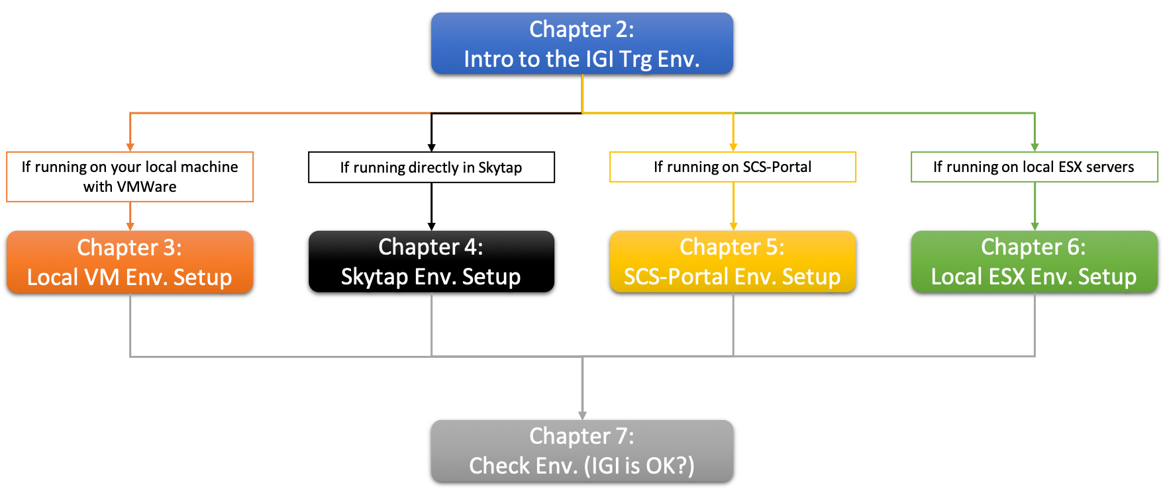

You should read Chapter 2 first to familiarize yourself with the environment, then Chapter 3/4/5/6 depending on how you’re running the environment, then finally run the steps in Chapter 7 to confirm IGI is running OK.

# Introduction to the IGI 5.2.5 Training Lab Environment

A common training lab environment is used for many IBM Security Identity Governance and Intelligence (IGI) training labs provided by the worldwide Technical Enablement team. This guide is for the training environment running on a local machine.

This section summarizes this training lab environment. The detailed setup/start up steps are later sections.

## Architecture and Components

The following figure is a high-level architecture of the major components and data flows for the lab environment:

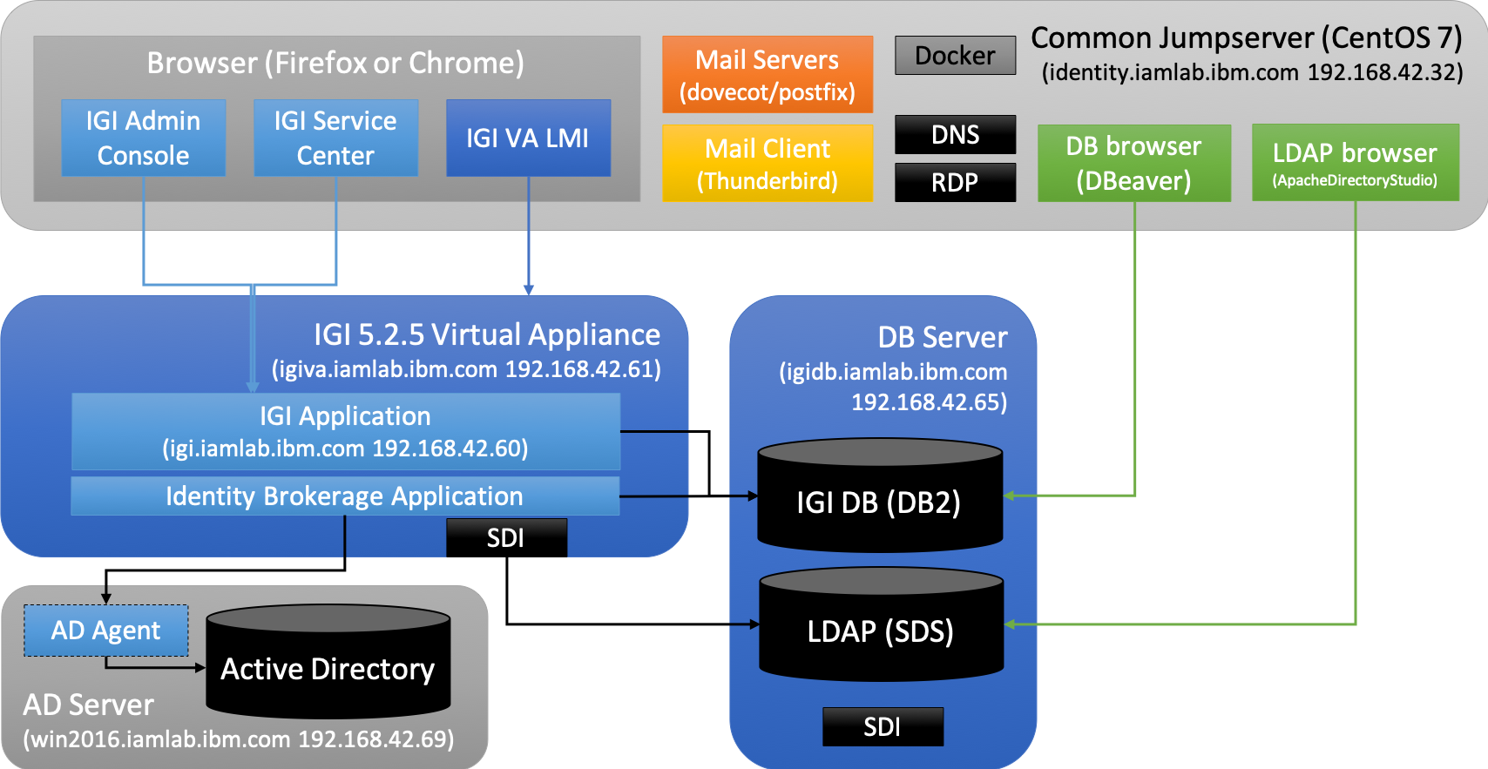

It consists of four virtual machines as described in the following sections.

If you are using this lab environment for other labs (like CIA and ISIQ) the following information will still apply.

## Virtual Machines

There are four VMs in this training environment; a common jumpserver, the two IGI server and one Windows Server.

### A Common Jumpserver

This CentOS 7 VM is designed to be the common server used in all labs. It is intended to act as the jump server where direct access to VMs is not possible (e.g. SCS-Portal or local ESX environments).

The VM contains a number of applications and utilities:

* Two browsers, Firefox and Chrome, that can be used to access the UIs. Firefox has an extensive set of shortcuts and is the primary browser for all labs
* Mail servers (SMTP and IMAP/POP) and a mail client (Thunderbird) for all email activity in IGI
* A DNS server for all identity-related iamlab.ibm.com IPs
* An RDP client for RDP-ing to the Windows server
* A database browser and an LDAP browser
* Docker CE for use in CIA, ISIQ and future labs.

More information on using the utilities can be found in Appendix C – Environment Tools and Utilities.

### IGI 5.2 Virtual Appliance

The first VM is the IGI Virtual Appliance (VA). It’s currently at IGI 5.2.5.0. It includes the application servers (WebSphere Application Server – Liberty) and the on-board Security Directory Integrator instance. The application hosts the two IGI user interfaces and the Virtual Appliance Local Management Interface (and Command Line Interface – not shown).

### IGI Data Server (DB Server)

The IGI Data Server is a Linux (CentOS 6.5) VM hosting two datastores:

1. The IGI database (DB2 10.5.0.5) used by both IGI and the Broker with some training data, and
2. A Security Directory Server (SDS) instance used as a provisioning target

In prior versions of IGI, the LDAP was used by the broker as the provisioning cache. This is no longer required with 5.2.5 and that part of the directory is not used.

There is also a Tivoli Directory Integrator (7.1.1.5) instance (not shown) that could be used for for running broker adapters, but the current set of labs use the on-board TDI.

This VM is based off the old 5.2.2 DISTRO image, but with the application components disabled.

### Windows 2016 Server (AD Server)

There is a Windows 2016 Server with Active Directory that is used for some of the provisioning labs.

The guides for specific labs will tell you whether you need to have the AD Server running or not. For most labs you will not need to have it running.

The VM has the AD Agent (7.1.31) already installed and running.

## Memory Recommendations

If running this lab with local VMs, you may need to check/change the memory allocated to the VMs. If you are running on one of the other training platforms, you don’t need change anything.

This lab uses VMware virtual machines and was designed for host machines with at least 16 Gb of memory. The common jumpbox server is configured with 2GB memory, the two IGI VMs are configured by default at 4GB memory, the Windows Server is configured with 2GB memory.

If running on a 16GB machine, you might want to shut down other processes. If you have more memory available, you can increase the memory allocated to each, but the labs will run ok with the allocations as shown.

## VMWare and Networking

To run these labs locally (on your own machine) you will need VMware Workstation, Fusion or Player. If you are running on one of the other training platforms, you don’t need to worry about VMWare or networking.

Whilst it is recommended to use either VMWare Fusion (Mac) or VMWare Workstation (Windows or Linux), the environment can run locally on VMWare Player. However additional steps are required to configure the networking for Player. See A.2 – Using VMWare Player with the Training Image for details.

If running the labs locally, the next chapter describes the networking configuration. If running the environment on any of the other training platforms, you don’t need to worry about the networking.

DNS is configured to resolve all of the ***.iamlab.ibm.com addresses to their 192.168.42.*** addresses. This DNS runs on the common jumpserver (identity.iamlab.ibm.com, 192.168.42.32). IGI is configured to use it, so you will probably need to have it running, even if you access the IGI UIs via your local browser.

## Accounts

The following accounts are used in the training environment:

|  |  |  |
| --- | --- | --- |
| **Account** | **Userid** | **Password** |
| IGI Virtual Appliance login | Admin | Passw0rd! |
| IGI VM command line | igi | igi |
| IGI Admin Console | admin | admin |
| IGI Service Center | *Various* | Passw0rd |
| LDAP (instance is igildap) | cn=root | igi |
| DB2 (instance is igi_db) | igacore | ideas |
| Win Server 2016 | NetworkAdmin | Passw0rd |

With IGI 5.2.4, OIDC has been introduced for the IGI logins. If going via the OIDC (default) login for the IGI VA, you will need to use admin/admin. If you are going directly into the VA LMI login page (there a link in Firefox) you use admin/Passw0rd! (don’t forget the exclamation).

If you come across any other logins, it’s a safe bet that the password will be one of the ones above.

## Student Files

There is a **Home > studentfiles > igi** folder for files needed for the labs and lab guides (shortcut to **Home** on the desktop). You can access this from the desktop.

## Where to Next?

Now that you’re familiar with the training environment you need to start it up. The setup instructions depend on the training platform you’re using:

* If using **local VMs**, skip to Chapter 3: Local VM Environment Setup
* If using **Skytap**, skip to Chapter 4: Skytap Environment Setup
* If using **SCS-Portal**, skip to Chapter 5: SCS-Portal Environment Setup, or
* If using a **Local ESX Server**, skip to Chapter 6: Local ESX Server Environment Setup

If you have been given a URL to access that looks something like <https://labs.edu.ihost.com/5002253.s1/abcd>, then you are using SCS-Portal and your instructor has already created the environment for you and you would follow the instructions in Chapter 5.

If you’re in a training class and have been given an individual IP address and told to RDP to it, then you are using a local ESX Server and should follow the instructions in Chapter 6.

Chapter 7: Check the IGI Application is Working is common as it checks that the IGI components are running. It’s the same no matter which training platform you’re running on. When you have completed the steps in Chapter 7 you are ready to start specific labs.

# Local VM Environment Setup

The section details the steps to setup the local VMs running on your local machine. If you are using one of the other training platforms (Skytap, SCS-Portal or local ESX servers), you should skip this chapter and go to the relevant chapter of this document.

The steps to setup the Local VM environment are:

1. Check your machine meets the minimum requirements
2. Download the compressed VM files
3. Expand the VMs
4. Check the VM memory allocation
5. Check the Networking
6. Start the IGI Data Server VM
7. Start the IGI Virtual Appliance VM
8. Set the VA time
9. (optionally) Start the Windows Server VM
10. Check connectivity

The environment will run on VMWare Workstation (Windows or Linux) and VMWare Fusion (Mac). It has also been run on VMWare Player (Windows) and has unique network setup steps (see A.2 – Using VMWare Player with the Training Image).

The following sections assume familiarity with your flavor of VMWare (Workstation or Fusion). If in doubt, check with the instructor or a colleague.

## Check your Machine Meets the Minimum Requirements

Your system will need to meet the following requirements:

* At least 16GB RAM
* At least 130GB of free disk
  + This includes space to download and uncompress the 7-zipped images (if you remove the 7-zipped files before you start the VMs you will only need ~100GB
  + If you don’t need the Windows 2016 (AD) server you only need ~75GB for all files and ~60GB once the 7-zipped files have been removed
* VMWare Workstation or Fusion (recommend Workstation 11.x or better, Fusion 8.5.x or better)

You may also need

* SSH client, like PuTTY to ssh into the VM
* SQL client to view the database (there is one in the common jumpserver image)
* FTP client, like Filezilla, to copy files to the VM
* Text editor, like Notepad, for making text changes
* LDAP browser for querying the directory (there is one in the common jumpserver image)

When needed the lab guides for specific labs will highlight them.

The common jumpserver image also contains the mail server and client. You could configure a local client to access the mail server on identity.iamlab.ibm.com (192.168.42.32) but it’s not necessary and we won’t cover it here.

## Download the Compressed VM Files

* The VMs may have been provided to you on a USB stick. If not, they can be downloaded from <https://ibm.box.com/v/IGI-TrainingVM-525>. Copy them to your local machine.

## Expand the VMs

The VMs are provided in a compress (7zip) format. There will be multiple files named like <VM name>.7z.001, <VM name>.7z.002, <VM name>.7z.003 etc.

You will need 7zip file manager to extract these files. Note, you only extract the first file – 7zip will read all the other files. If you were given the VMs on a USB stick, there will be a copy of 7zip on it. Otherwise you may need to download the tool.

* Decompress the environment 7z file using 7z
* (optionally) put the environment VMWare folder in your Virtual Machines folder
* Open the VMs **but do not start them yet** (open in VMWare, instead of double-clicking the vmx file)

## Check the VM memory allocation

As mentioned earlier, the VMs are configured with 4GB (for the IGI VA and IGI Data Server VMs) and 2GB (for the common jumpserver and AD Server VMs).

If memory is limited and you can’t shut down other software, you may need to reduce the IGI VMs down to 3GB each, but they will be slow. If you are running on a machine with 24GB or 32GB of memory, you may want to give the IGI VMs more memory.

* Check memory allocated to all VMs and adjust if necessary

## Check the Networking Configuration

All IP addresses are hardcoded to be in the “192.168.42.0” subnet. This is the same subnet used for all the IAM labs from the tech sales enablement team (Jon Harry, David Edwards). If you have already used other VMs from us, you will probably have networking setup correctly.

The VMs are configured with hosts files and DNS to allow the use of the following hostnames:

* igi.iamlab.ibm.com = 192.168.42.60
* igiva.iamlab.ibm.com = 192.168.42.61
* igidb.iamlab.ibm.com = 192.168.42.65
* win2016.iamlab.ibm.com = 192.168.42.69 (but internally configured as demo.com)

All VMs are configured to use the default NAT network (vmnet8). If your default NAT network (vmnet8) does not use the 192.168.42.0 subnet you have two options:

1. Change the default NAT/vmnet8 to use this subnet. No network changes needed for each VM.
2. Create a new vm network with 192.168.42.0/24 AND change the networking for each VM.

The following sections walk through checking your network configuration, and if it needs changing how to change it or setup a new network (for both Workstation and Fusion).

### Check and Set Your VM Networking

If the default NAT (vmnet8) is set to 192.168.42.0 then you don’t need to do anything.

The following sections describe how to check/set the default NAT for each of VMWare Workstation and VMWare Fusion. Follow the steps for the VMWare product you’re using.

#### Check and Set VMWare Workstation (Windows/Linux) Networking

If you are using VMWare Workstation on Windows or Linux:

* Open VMWare Workstation and select **Edit > Virtual Network Editor**
* Find the default NAT network (VMNet8) and select it
* Check the following values:
* NAT (shared host’s IP address with VMs)
* Connect a host virtual adapter to this network
* Use local DHCP service to distribute IP address to VMs
* Subnet IP – 192.168.42.0
* Subnet Mask – 255.255.255.0

This is shown below…

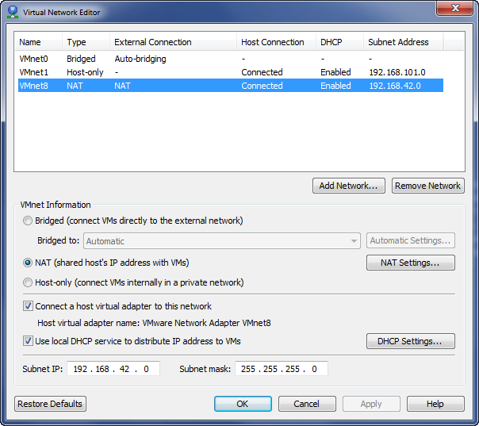



You don’t need to set/change the “DHCP Settings…” as the VMs use fixed IPs.

If the settings are correct, your VM networking is setup correctly and you can proceed to the next section.

* If you need to modify the default NAT, change it to match the settings shown above and click Apply

If for some reason you don’t want to change the default NAT to the needed subnet, you can setup a new VMWare network and then change the network interfaces for each VM to use the new network. This is described in A.1 – Configure New Network in VMWare and Change VMs to Use It on page 37.

#### Check and Set VMWare Fusion (Mac) Networking

Unfortunately Fusion does not have a Virtual Network Editor that shows the network configuration for the default NAT network (it does for any custom networks configured).

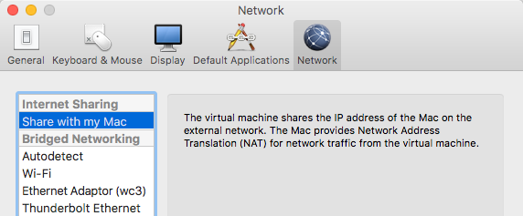

You need to use a command line (shell) to check:

* Open a Terminal session on your Mac
* Edit the file /Library/Preferences/VMware\ Fusion/networking. You can use your editor of choice (like vi or nano) and you may need to use sudo . For example:

davidedw:~ davidedw$ sudo vi /Library/Preferences/VMware\ Fusion/networking

* Locate the entries for vmnet8

They will be at the bottom of the file:

answer VNET_8_DHCP yes

answer VNET_8_DHCP_CFG_HASH CF53FA19F2149A40EB27C901AC3DC2C094A61FB7

answer VNET_8_HOSTONLY_NETMASK 255.255.255.0

answer VNET_8_HOSTONLY_SUBNET 192.168.42.0

answer VNET_8_NAT yes

answer VNET_8_VIRTUAL_ADAPTER yes

If the settings are as above (important are the NETMASK and SUBNET settings) then the default NAT (vmnet8) network is configured correctly and you can proceed to the “Start the IGI Data Server” section.

If you need to change the default NAT:

* Edit the file and make the changes, then save/exit
* Restart VMWare Fusion to apply the network changes

Note – this is covered in a VMWare support article “Modifying the DHCP settings of vmnet1 and vmnet8 in Fusion (1026510)” at <https://kb.vmware.com/selfservice/microsites/search.do?language=en_US&cmd=displayKC&externalId=1026510>.

If for some reason you don’t want to change the default NAT to the needed subnet, you can setup a new VMWare network and then change the network interfaces for each VM to use the new network. This is described in A.1 – Configure New Network in VMWare and Change VMs to Use It on page 37.

## Start and Check the VMs

The four VMs are all named “*<name>-<createdate>*”. At the time of writing they are:

* Common Jumpserver – ***Identity-Docker-20190131***
* DB Server – ***IGI525-Data-20190305***
* IGI 5.2.5 Virtual Appliance – ***IGI525-VA-20190305***
* AD Server – ***Win2016-AD-20190305***

The images you have may have later create dates.

The following sections walk through starting up the VMs in the correct order; the Common Jumpserver, then the DB Server, then the IGI VA and finally (if needed) the AD Server. IGI expects the DNS to be running (on the Jumpserver) and the IGI VA/application expects the database to be running.

### Start the Common Jumpserver

The common jumpserver is a CentOS 7 VM containing browsers used to access the IGI UIs and other utilities used by some of the labs. It also contains the DNS server used by the other VMs, so should be started first.

* Start the **Identity-Docker VM** in the Virtual Machine Library
* When the CentOS splash page comes up, click on the **Demo User** tile
* In the Password field enter the password of Passw0rd and click the Sign In button (or just hit enter)
* Wait until the desktop is shown

You can ignore/close any SELinux messages that appear. There is nothing else on this server we’re waiting for, so you can proceed to starting the IGI VMs.

### Start the IGI Data Server VM

The IGI Data Server VM contains the IGI datastores. It needs to be running before starting the Virtual Appliance.

* Start the **IGI525-Data VM** in the Virtual Machine Library

The image will go through a Linux boot up. When it’s finished it will present the IP address and a login prompt.

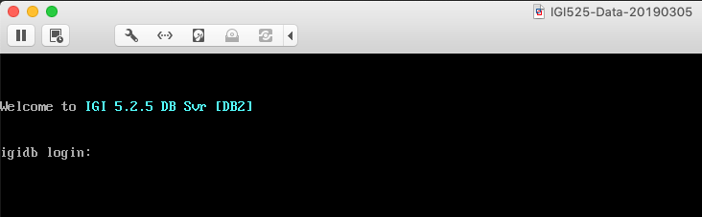

* Log in with igi/igi
* Run a ps –ef | grep db2 command to check both datastores (IGI DB and IGI LDAP) are running

[igi@igidb ~]$ ps -ef | grep db2

root 1613 1 0 07:49 ? 00:00:01 db2wdog

igiinst 1615 1613 1 07:49 ? 00:00:02 db2sysc

root 1621 1613 0 07:49 ? 00:00:00 db2ckpwd

root 1622 1613 0 07:49 ? 00:00:00 db2ckpwd

root 1623 1613 0 07:49 ? 00:00:00 db2ckpwd

igiinst 1625 1613 0 07:49 ? 00:00:00 db2vend (PD Vendor Process - 1)

igiinst 1633 1613 0 07:49 ? 00:00:00 db2acd ,0,0,0,1,0,0,0,0000,1,0,995bc4,14,1e014,2,0,1,41fc0,0x210000000,0x210000000,1600000,10002,2,a0012

root 1894 1 0 07:49 ? 00:00:01 db2wdog

igildap 1896 1894 5 07:49 ? 00:00:08 db2sysc

root 1902 1894 0 07:49 ? 00:00:00 db2ckpwd

root 1903 1894 0 07:49 ? 00:00:00 db2ckpwd

root 1904 1894 0 07:49 ? 00:00:00 db2ckpwd

igildap 1906 1894 0 07:49 ? 00:00:00 db2vend (PD Vendor Process - 1)

igildap 1914 1894 0 07:49 ? 00:00:00 db2acd ,0,0,0,1,0,0,0,0000,1,0,995bc4,14,1e014,2,0,1,41fc0,0x210000000,0x210000000,1600000,28005,2,138023

igi 2566 2464 0 07:52 pts/0 00:00:00 grep db2

If you see a display similar to above with db2sysc processes for both igiinst and igildap, then both datastores are running.

### Start the IGI Virtual Appliance VM

The IGI Virtual Appliance is started once the IGI Data Store VM is running.

* Start the **IGI525-VA VM** in the Virtual Machine Library

The image will go through the appliance boot up. When it’s finished it will present a login prompt.

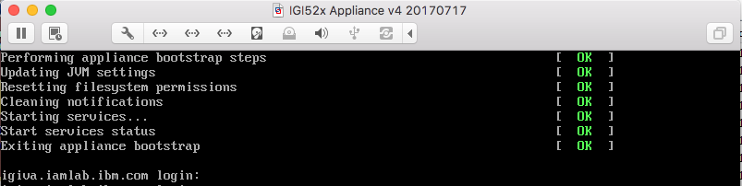

* Log in with admin/Passw0rd! (don’t forget the exclamation mark)

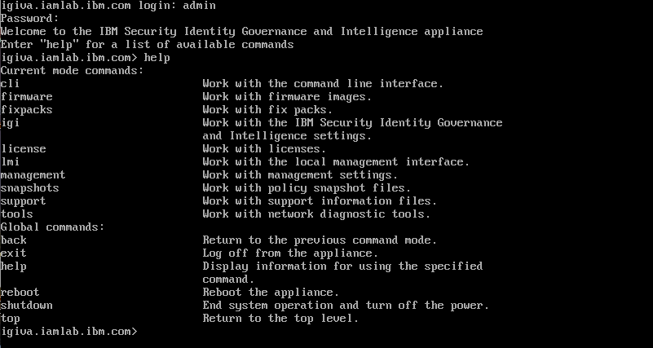

The Virtual Appliance is running. You can enter help to see the list of command options.



This completes the startup of the IGI Virtual Appliance. In the final chapter of this document we will check that the IGI application has started correctly.

### (Optionally) Start the AD Server VM

If the lab you’re running needs the AD server, you will need to start it. If your lab guide doesn’t say it’s needed, then you don’t need to start it up.

If you do want to use it:

* Start the **Win2016-AD VM** in the Virtual Machine Library
* Wait for the (endless) “Applying computer settings” to do its thing
* When the beach scene appears, press CTRL + ALT + DELETE to login
* For **NetworkAdmin** enter a password of “Passw0rd”
* Wait for the desktop to display

When the Windows desktop appears, you are ready to test.

### Check Networking and Name Resolution

* Return to the Common Jumpserver and Open a Terminal session
* In the terminal window test the connectivity and name resolution with the following commands (note Ctrl+c to end command):
  + Run the command ping igidb.iamlab.ibm.com (it should resolve to 192.168.42.65) to test the connection to the IGI Data Server,
  + Run the command ping igiva.iamlab.ibm.com (it should resolve to 192.168.42.61) to test the connection to the IGI Virtual Appliance interface,
  + Run the command ping igi.iamlab.ibm.com (it should resolve to 192.168.42.60) to test the connection to the IGI application interface, and
  + If using the AD Server, run the command ping win2016.iamlab.ibm.com (it should resolve to 192.168.42.69) to test the connection to the AD server

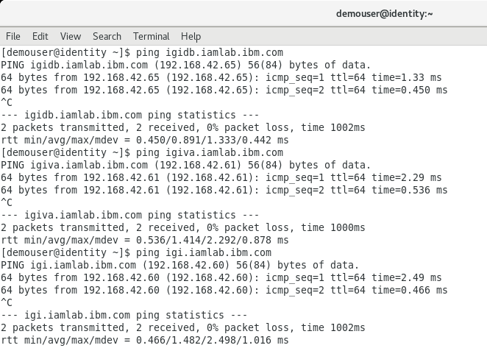

If you get a message saying, “Destination host unreachable” that means there is a networking issue. Review your networking configuration.

If you can ping all the VMs you are ready to test IGI. Proceed to Chapter 7: Check the IGI Application is Working.

# Skytap Environment Setup

An environment with all components is built in Skytap and ready to use. This section covers creating an environment from the template and starting the environment.

The section details the steps to setup the VMs running in Skytap. If you are using one of the other training platforms (local VMs, SCS-Portal or local ESX servers), you should go to the relevant chapter of this document.

There are multiple Skytap templates for the training image:

* ***IAM: IGI 52x Training Env | 040 | INSTANCE*** – this is the main training environment. All of the IGI-only labs use this image. If in doubt, select this one.
* ***IAM: IGI 52x Training Env - Integration lab done | 040 | INSTANCE*** – this is a copy of the main training environment that has had the first two lab parts for the Basic/Standard course done. You should only use this image if you’re running the Basic/Essentials course labs (Lab04) and you have progressed past Lab04 part 2.

Note that the IGI Training environment in Skytap does not have external access enabled – you need to use the Common Jumpserver VM to access the IGI VMs.

## Create an Environment from the Template

The IGI training environment template is called “*IAM: IGI 52x Training Env | 040 | INSTANCE*”.

* Log into Skytap
* Go to **Environments > Templates** and find “*IAM: IGI 52x Training Env | 040 | INSTANCE*” or use the “TREFde0001” tag ([https://cloud.skytap.com/templates?query=name%3ATREFde0001*](https://cloud.skytap.com/templates?query=name%3ATREFde0001*) )
* Select the Environment and click the **New Environment** button on the right

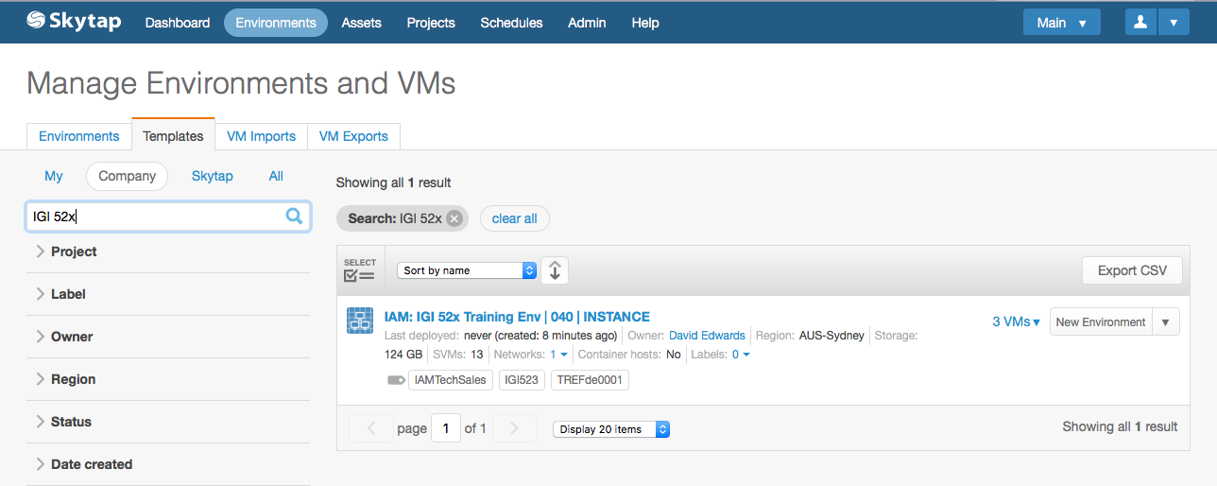

This screenshot is an older example – use the relevant IGI 5.2.5 template listed above.

* Give your environment a name and click **Deploy**

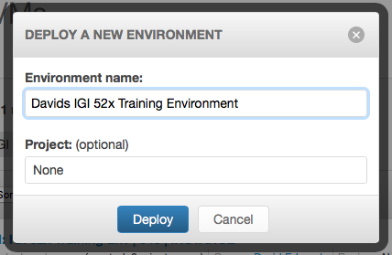

Your training environment is ready to use.

## Starting the Training Environment

The VMs in the environment are already configured with the correct networking and memory/CPU allocation, so you can just start it.

* Open your new environment (it may already be open from when you created it, otherwise select it from your environment list)

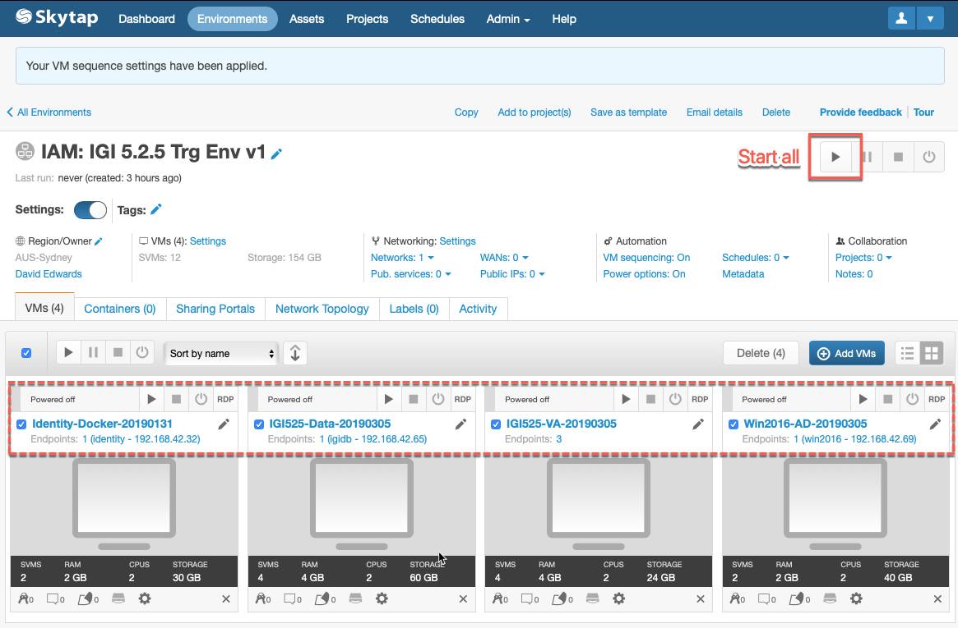

You can see the four VMs in the environment; the Common Jumpserver (“Identity-Docker-20190131” in this case), the IGI DB Server (“IGI525-Data-20190305”), IGI 5.2.5 Virtual Appliance (“IGI525-VA-20190305”) and the AD Server (“Win2016-AD-20190305”). The Common Jumpserver should be running before the others, the IGI data server needs to be running before the appliance is started, if needed the AD Server can be started at any time.

You can start them individually or use the “Start all” button on the top right of the page. The Start all button will first start the Common Jumpserver, wait a minute, then start the DB Server, then wait a minute and start the IGI 5.2.5 Virtual Appliance. It will not start the AD Server – you need to start that manually.

* Start the VMs individually or use the Start all button

If you use the Start all you will see



The running sequence stage section will be displayed, and busy icons will appear beside the environment title and the titles for each VM. The VM windows will change from a grey background, to a blue background (as they are being started), to a green background (started).

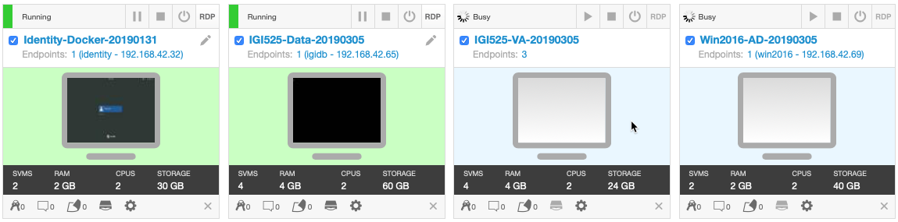

When all three VMs have a green background, they are started. Next, we need to check that they started.

## Check VMs

When the VMs have come up, there are some simple steps to check they are ready to use.

### Check Common Jumpserver VM

To check the Common Jumpserver VM

* Click on the **Identity-Docker-20190131** title or the monitor icon below it to open a session with the server
* Go to the session, click inside the window and hit enter to bring up the CentOS panel showing the **Demo User** and click the **Demo User**
* One the next page in the **Password** field enter Passw0rd
* Wait until the desktop is shown

We don’t need to check if specific services are running. However, we do need to check the networking and name resolution.

To check networking and name resolution:

* Open a Terminal window (double-click the Terminal icon)
* In the terminal window test the connectivity and name resolution with the following commands (note Ctrl+c to end command):
  + Run the command ping igidb.iamlab.ibm.com (it should resolve to 192.168.42.65) to test the connection to the IGI Data Server,
  + Run the command ping igiva.iamlab.ibm.com (it should resolve to 192.168.42.61) to test the connection to the IGI Virtual Appliance interface,
  + Run the command ping igi.iamlab.ibm.com (it should resolve to 192.168.42.60) to test the connection to the IGI application interface, and
  + If using the AD Server, run the command ping win2016.iamlab.ibm.com (it should resolve to 192.168.42.69) to test the connection to the AD server

[demouser@identity ~]$ ping igidb.iamlab.ibm.com

PING igidb.iamlab.ibm.com (192.168.42.65) 56(84) bytes of data.

64 bytes from 192.168.42.65 (192.168.42.65): icmp_seq=1 ttl=64 time=3.59 ms

64 bytes from 192.168.42.65 (192.168.42.65): icmp_seq=2 ttl=64 time=0.255 ms

^C

--- igidb.iamlab.ibm.com ping statistics ---

2 packets transmitted, 2 received, 0% packet loss, time 1001ms

rtt min/avg/max/mdev = 0.255/1.923/3.591/1.668 ms

[demouser@identity ~]$ ping igiva.iamlab.ibm.com

PING igiva.iamlab.ibm.com (192.168.42.61) 56(84) bytes of data.

64 bytes from 192.168.42.61 (192.168.42.61): icmp_seq=1 ttl=64 time=3.39 ms

64 bytes from 192.168.42.61 (192.168.42.61): icmp_seq=2 ttl=64 time=1.01 ms

^C

--- igiva.iamlab.ibm.com ping statistics ---

2 packets transmitted, 2 received, 0% packet loss, time 1001ms

rtt min/avg/max/mdev = 1.013/2.206/3.399/1.193 ms

[demouser@identity ~]$ ping igi.iamlab.ibm.com

PING igi.iamlab.ibm.com (192.168.42.60) 56(84) bytes of data.

64 bytes from 192.168.42.60 (192.168.42.60): icmp_seq=1 ttl=64 time=1.69 ms

64 bytes from 192.168.42.60 (192.168.42.60): icmp_seq=2 ttl=64 time=0.232 ms

^C

--- igi.iamlab.ibm.com ping statistics ---

2 packets transmitted, 2 received, 0% packet loss, time 1001ms

rtt min/avg/max/mdev = 0.232/0.962/1.692/0.730 ms

You should see the iamlab.ibm.com addresses resolved to their 192.168.42.*** addresses (as highlighted). You should also see response times from the other servers.

If you have problems with pinging the DB Server, you should check that the eth0 definition hasn’t been blown away (a known issue with CentOS). See B.1 – IGI Data Server Loses eth0.

You can leave this session running as you will use it to confirm the application is running.

### Check DB Server VM

To check the DB Server VM

* Click on the **IGI525-Data-20190305** title (or click the monitor icon below it) to open a browser window/tab into that environment
* At the login prompt login with igi/igi
* Change directory to tools (cd tools)
* Check that the two database instances are running (ps –ef | grep db2)

[igi@igidb ~]$ ps -ef | grep db2

root 1613 1 0 07:49 ? 00:00:01 db2wdog

igiinst 1615 1613 1 07:49 ? 00:00:02 db2sysc

root 1621 1613 0 07:49 ? 00:00:00 db2ckpwd

root 1622 1613 0 07:49 ? 00:00:00 db2ckpwd

root 1623 1613 0 07:49 ? 00:00:00 db2ckpwd

igiinst 1625 1613 0 07:49 ? 00:00:00 db2vend (PD Vendor Process - 1)

igiinst 1633 1613 0 07:49 ? 00:00:00 db2acd ,0,0,0,1,0,0,0,0000,1,0,995bc4,14,1e014,2,0,1,41fc0,0x210000000,0x210000000,1600000,10002,2,a0012

root 1894 1 0 07:49 ? 00:00:01 db2wdog

igildap 1896 1894 5 07:49 ? 00:00:08 db2sysc

root 1902 1894 0 07:49 ? 00:00:00 db2ckpwd

root 1903 1894 0 07:49 ? 00:00:00 db2ckpwd

root 1904 1894 0 07:49 ? 00:00:00 db2ckpwd

igildap 1906 1894 0 07:49 ? 00:00:00 db2vend (PD Vendor Process - 1)

igildap 1914 1894 0 07:49 ? 00:00:00 db2acd ,0,0,0,1,0,0,0,0000,1,0,995bc4,14,1e014,2,0,1,41fc0,0x210000000,0x210000000,1600000,28005,2,138023

If you see a display similar to above with db2sysc processes for both igiinst and igildap, then both datastores are running.

* Close the browser window/tab for the DB Server

### Check IGI 5.2.5 Virtual Appliance VM

To check the IGI 5.2.5 Virtual Appliance VM

* Back on the Skytap environment view, click on the **IGI525-VA-20190305** title (or the monitor icon below it) to open a browser window/tab into that environment
* Login with admin/Passw0rd! (note exclamation mark)

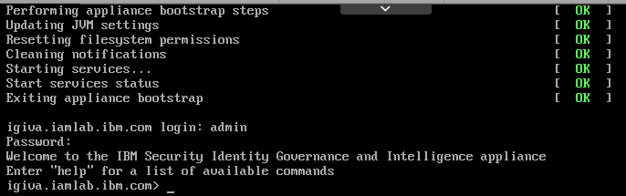

If this works, the appliance is ok.

* Close the browser window/tab for the IGI appliance

This environment is now ready to test the application. Proceed to Chapter 7: Check the IGI Application is Working.

# SCS-Portal Environment Setup

The Security CloudSpace Portal (aka. SCS-Portal, IBM Remote Lab Reservation, IRLP), <https://ibm.biz/scsportal> , is an IBM portal front-ending Skytap. It allows instances of Skytap templates (called “profiles”) to be scheduled for training and demo purposes. If you are using one of the other training platforms (local VMs, Skytap or local ESX servers), you should go to the relevant chapter of this document.

There are SCS-Portal profiles corresponding to the Skytap templates listed in the previous section:

* ***Security Solutions / DM0000184 – IAM: IGI 5.2.x Training Environment*** – this corresponds to the *IAM: IGI 52x Training Env | 040 | INSTANCE* and is the profile that should be used for all labs
* ***Security Solutions / DM0000225 – IAM: IGI 5.2.x Training Environment - Integration Lab Done*** – this corresponds to the *• IAM: IGI 52x Training Env - Integration lab done | 040 | INSTANCE* and is the profile that should only be used by people doing the Basic/Essentials labs (Lab04) and have progressed past Part 02 of the lab.

## Scheduling a Profile Instance

If you are in a training class, your instructor may have scheduled instances for you. If you have been given a URL (like https://labs.edu.ihost.com/nd.5002389.s1/ec4b) then you can skip the following and go straight to starting your environment.

To schedule a demo:

* Go to SCS-Portal (<https://ibm.biz/scsportal> ). The default page is the Schedule a Demo page
* Select Security Solutions for the **Curriculum unit** and select the **IGI Demonstration Profile** you need

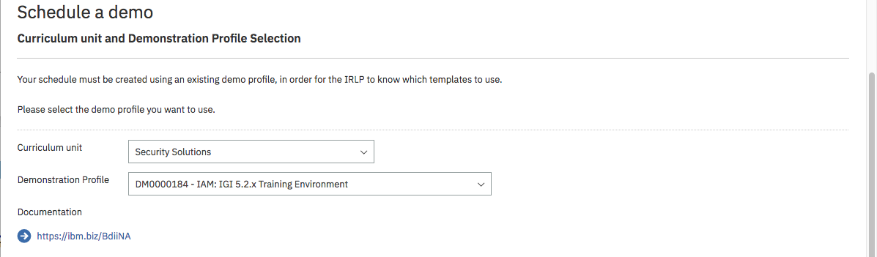

When you select the appropriate profile, the page will refresh, and you will see a documentation link as shown.

* Enter **Schedule information** based on your purpose for using the profile:
* **Demonstration Name** – you must give it a name
* **Opportunity number** – if this in support of a sales opportunity you should include an opportunity number. This is checked against a live DB. If there are problems, you can include it I the Customer name –or- Description field
* **User e-mail** – this will be your email
* **Contact e-mail** – this is used when instances are scheduled for other people (note – the owner of the profile will also get an email when an instance is scheduled)
* **Number of instances** – admins can select >1, all other users can only request a single instance (if you need multiples, you need to contact one of the admins)
* **Demo purpose** – select from one in the pull-down list
* **Customer name** -or- Description – this will depend on the purpose
* **Time zone** – it should default to your time zone
* **Start data** – either a future start date or you can specify Start now to have it instantly scheduled
* **End date** – the date it will automatically be removed. Note that the max duration for any instance is set when the profile is defined and will normally be 2-3 days. If you are running course (or personal training) longer than that you may need to schedule multiple instances or contact an admin to see if it can be extended

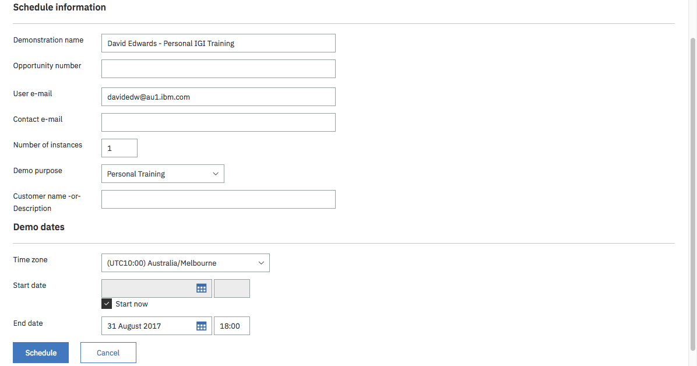

* Click **Schedule**

The page will be refreshed, and you will see a message indicating your instance has been booked.

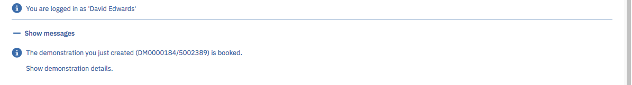

* Click on the **Show demonstration details** link

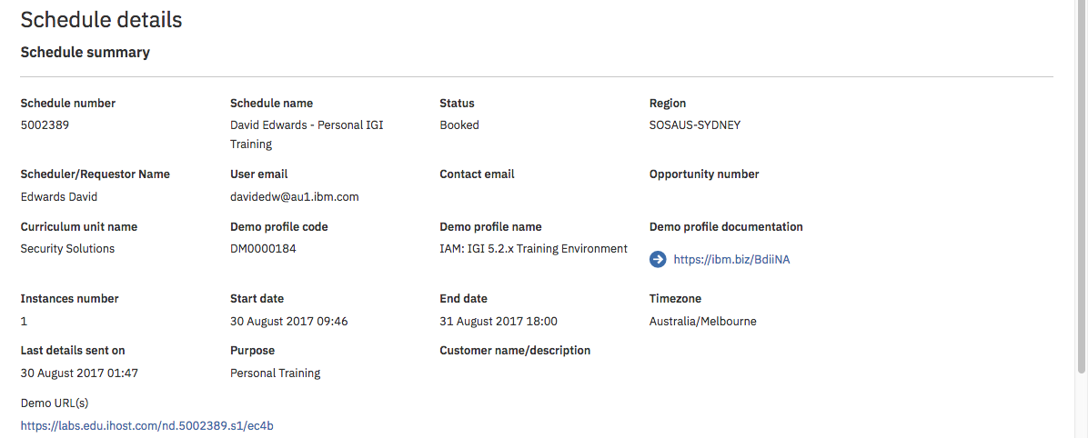

It shows all the details of your scheduled instance. Note the Demo URL(s) at the bottom. This is the link you use to access the instance.

## Accessing the Profile Instance

To access the profile instance:

* Click the Demo URL(s) link from the Schedule details page (or given to you by your instructor).

This will take you into Skytap.

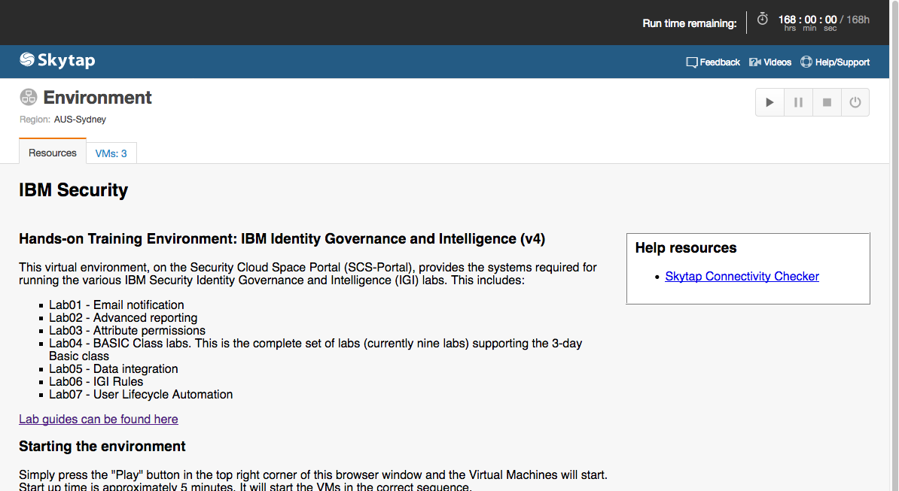

The top of the page shows you how much time you have remaining for this instance.

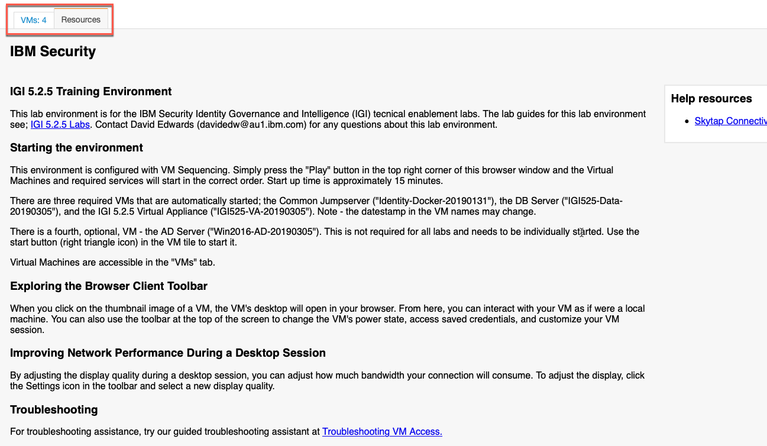

The main part of the page provides instructions (“Resources”) for this instance. It will look different for different profiles and covers lab guides, startup instructions and other useful information.

There is another tab that shows the VMs for this instance.

* Select the **VMs** tab

This view shows the VMs in the training environment.

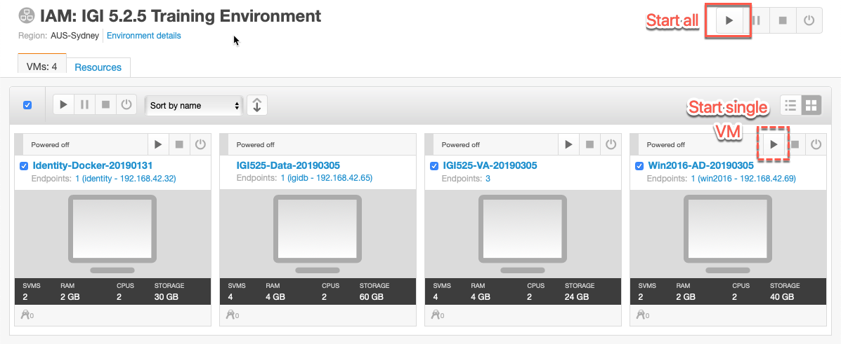

The environment is now ready to start.

## Starting the Training Environment

To start the required VMs in the training environment:

* Click the Start all button (the right arrow button on the top right of the page)

If you need to start the AD Server you will need to start it individually by using the Start single VM button (right arrow in the Win2016-AS-20190305 tile).

The background of each VM will change to light blue as it’s starting up.

As the VMs start, the background will change to green. In most IGI training environments there is a startup sequence (e.g. data server must be running before the virtual appliance) so you might see some VMs start before others.

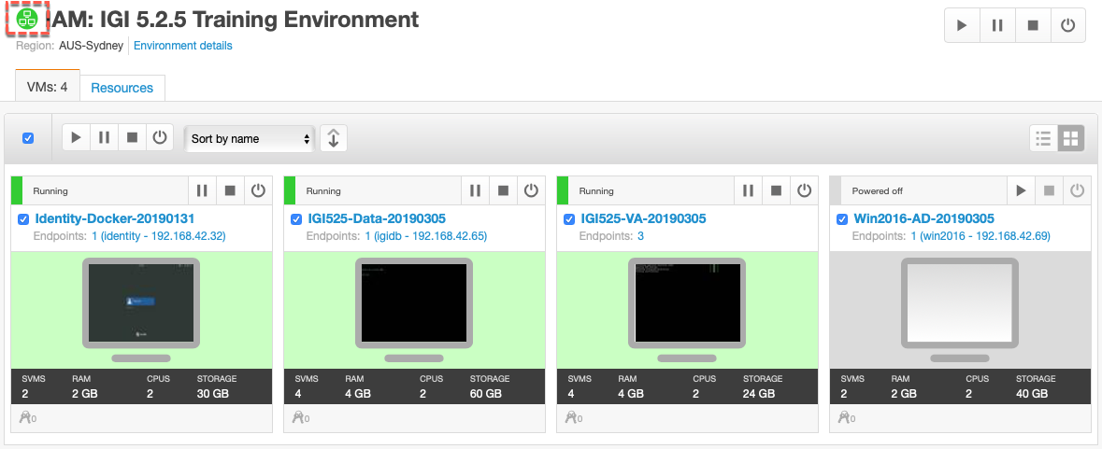

When all VMs are started, the Environment icon will change to green.

We will now test the three required images.

## Check VMs

Now that the VMs have come up, there are some simple steps to check they are ready to use.

### Check Common Jumpserver VM

To check the Common Jumpserver VM

* Click on the **Identity-Docker-20190131** title or the monitor icon below it to open a session with the server
* Go to the session, click inside the window and hit enter to bring up the CentOS panel showing the **Demo User** and click the **Demo User**
* One the next page in the **Password** field enter Passw0rd
* Wait until the desktop is shown

We don’t need to check if specific services are running. However, we do need to check the networking and name resolution.

To check networking and name resolution:

* Open a Terminal window (double-click the Terminal icon)
* In the terminal window test the connectivity and name resolution with the following commands (note Ctrl+c to end command):
  + Run the command ping igidb.iamlab.ibm.com (it should resolve to 192.168.42.65) to test the connection to the IGI Data Server,
  + Run the command ping igiva.iamlab.ibm.com (it should resolve to 192.168.42.61) to test the connection to the IGI Virtual Appliance interface,
  + Run the command ping igi.iamlab.ibm.com (it should resolve to 192.168.42.60) to test the connection to the IGI application interface, and
  + If using the AD Server, run the command ping win2016.iamlab.ibm.com (it should resolve to 192.168.42.69) to test the connection to the AD server

[demouser@identity ~]$ ping igidb.iamlab.ibm.com

PING igidb.iamlab.ibm.com (192.168.42.65) 56(84) bytes of data.

64 bytes from 192.168.42.65 (192.168.42.65): icmp_seq=1 ttl=64 time=3.59 ms

64 bytes from 192.168.42.65 (192.168.42.65): icmp_seq=2 ttl=64 time=0.255 ms

^C

--- igidb.iamlab.ibm.com ping statistics ---

2 packets transmitted, 2 received, 0% packet loss, time 1001ms

rtt min/avg/max/mdev = 0.255/1.923/3.591/1.668 ms

[demouser@identity ~]$ ping igiva.iamlab.ibm.com

PING igiva.iamlab.ibm.com (192.168.42.61) 56(84) bytes of data.

64 bytes from 192.168.42.61 (192.168.42.61): icmp_seq=1 ttl=64 time=3.39 ms

64 bytes from 192.168.42.61 (192.168.42.61): icmp_seq=2 ttl=64 time=1.01 ms

^C

--- igiva.iamlab.ibm.com ping statistics ---

2 packets transmitted, 2 received, 0% packet loss, time 1001ms

rtt min/avg/max/mdev = 1.013/2.206/3.399/1.193 ms

[demouser@identity ~]$ ping igi.iamlab.ibm.com

PING igi.iamlab.ibm.com (192.168.42.60) 56(84) bytes of data.

64 bytes from 192.168.42.60 (192.168.42.60): icmp_seq=1 ttl=64 time=1.69 ms

64 bytes from 192.168.42.60 (192.168.42.60): icmp_seq=2 ttl=64 time=0.232 ms

^C

--- igi.iamlab.ibm.com ping statistics ---

2 packets transmitted, 2 received, 0% packet loss, time 1001ms

rtt min/avg/max/mdev = 0.232/0.962/1.692/0.730 ms

You should see the iamlab.ibm.com addresses resolved to their 192.168.42.*** addresses (as highlighted). You should also see response times from the other servers.

If you have problems with pinging the DB Server, you should check that the eth0 definition hasn’t been blown away (a known issue with CentOS). See B.1 – IGI Data Server Loses eth0.

You can leave this session running as you will use it to confirm the application is running.

### To Switch Between VMs or See All VMs

When you clicked the Common Jumpserver icon to open a session on that VM, you replaced the all VMs view from earlier. You can switch back to that view or jump to sessions in the other VMs by clicking the “Environment VMs” icon (two monitors icon) in the menu bar at the top of the current session.

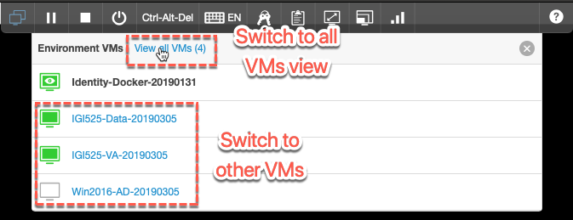

You can click “View all VMs (4)” to return to the all VMs view or click on one of the other VMs to go to a session in that VM.

* Click on the **View all VMs (4)** link

### Check DB Server VM

To check the DB Server VM

* Click on the **IGI525-Data-20190305** title (or click the monitor icon below it) to open a session into that VM
* At the login prompt login with igi/igi
* Change directory to tools (cd tools)
* Check that the two database instances are running (ps –ef | grep db2)

[igi@igidb ~]$ ps -ef | grep db2

root 1613 1 0 07:49 ? 00:00:01 db2wdog

igiinst 1615 1613 1 07:49 ? 00:00:02 db2sysc

root 1621 1613 0 07:49 ? 00:00:00 db2ckpwd

root 1622 1613 0 07:49 ? 00:00:00 db2ckpwd

root 1623 1613 0 07:49 ? 00:00:00 db2ckpwd

igiinst 1625 1613 0 07:49 ? 00:00:00 db2vend (PD Vendor Process - 1)

igiinst 1633 1613 0 07:49 ? 00:00:00 db2acd ,0,0,0,1,0,0,0,0000,1,0,995bc4,14,1e014,2,0,1,41fc0,0x210000000,0x210000000,1600000,10002,2,a0012

root 1894 1 0 07:49 ? 00:00:01 db2wdog

igildap 1896 1894 5 07:49 ? 00:00:08 db2sysc

root 1902 1894 0 07:49 ? 00:00:00 db2ckpwd

root 1903 1894 0 07:49 ? 00:00:00 db2ckpwd

root 1904 1894 0 07:49 ? 00:00:00 db2ckpwd

igildap 1906 1894 0 07:49 ? 00:00:00 db2vend (PD Vendor Process - 1)

igildap 1914 1894 0 07:49 ? 00:00:00 db2acd ,0,0,0,1,0,0,0,0000,1,0,995bc4,14,1e014,2,0,1,41fc0,0x210000000,0x210000000,1600000,28005,2,138023

If you see a display similar to above with db2sysc processes for both igiinst and igildap, then both datastores are running.

* As done earlier, switch back to the All VMs view

### Check IGI 5.2.5 Virtual Appliance VM

To check the IGI 5.2.5 Virtual Appliance VM

* Back on the all VMs view, click on the **IGI525-VA-20190305** title (or the monitor icon below it) to open a session into that VM
* Login with admin/Passw0rd! (note exclamation mark)



If this works, the appliance is ok.

* Close the browser window/tab for the IGI appliance

Your environment is now ready to test the application. Proceed to Chapter 7: Check the IGI Application is Working.

# Local ESX Server Environment Setup

If you are in a class, such as a Sales Academy or Master Skills class, you may be using a local VMWare ESX server infrastructure to run the training environment. If your instructor has given you an IP address and told you to RDP into the IP address, you are running on the local ESX server infrastructure.

The section details the steps to setup the VMs running in the local ESX environment. If you are using one of the other training platforms (local VMs, Skytap or SCS-Portal), you should go to the relevant chapter of this document.

You may hear this local ESX environment referred to as “SCS-Local”

This training platform is a little different to the others – the VMs will already be started for you and you can only connect into the Common Jumpserver VM via RDP (and then connect to the other systems from there).

## Getting Access to the Training Environment

To access the IGI lab environment VMs on the local ESX server(s) you will need to access the dedicated wifi and then RDP into the IP you have been given. These steps, and the required software, is described in the following sections.

### Connect to the Dedicated IGI Wireless Network

To access the images hosted on the local ESX server, you will need to be connected to the dedicated IGI wireless network.

* Connect to the network. Wireless network is “**igi**” (you will be given a password)

### Understanding the VMs and Local Access

The same four VMs available on the other training platforms are available in the local ESX environment; the Common Jumpserver (“identity.iamlab.ibm.com”), the DB Server (“igidb.iamlab.ibm.com”), the IGI 5.2.5 Virtual Appliance (“igiva.iamlab.ibm.com”) and the optional AD Server (“win2016.iamlab.ibm.com”).

The Common Jumpserver (a CentOS 7 image) is considered the “jump box” – it is the machine you will access to run all of the labs. It must be connected to via RDP. Most of the labs will use the Firefox browser to access the IGI UIs.

The Windows Server 2016 image is just an AD system with limited other Windows services installed. You can RDP to it from the Common Jumpserver. Details of how to do this can be found in C.3 – RDP Client (to RDP from Within the Environment).

The two IGI VMs (DB Server and 5.2.5 Virtual Appliance) are used but cannot be connected to as in other training platforms. To access the command line for these VMs you need to SSH from the Common Jumpserver, as described in the sections below.

### Software to RDP to the Windows Server

You will need to use a Remote Desktop connection (Remote Desktop Services, using RDP), running on your own laptop, to connect to the lab systems. All the lab work will be performed from these systems.

If you are running a Windows laptop the required RDP client software is part of the operating system; you do not need additional software.

If you are running a Mac you will need to install the Windows RDP client, called the "Microsoft Remote Desktop" from the Apple App Store (iTunes: <https://itunes.apple.com/us/app/microsoft-remote-desktop/id1295203466?mt=12>).

If you are running on Linux, you will need to find and install your own RDP client.

### Connecting to the Windows Server via RDP on Mac

Once you have an RDP client running you will need to connect to the Common Jumpserver image with the IP address your instructor has given you. The following details are for the Mac RDP client linked-to above.

When configuring the RDP client, you will only need the PC Name (which is that network IP address for the Windows Server 2008R2 image). A sample RDP desktop configuration is shown below.

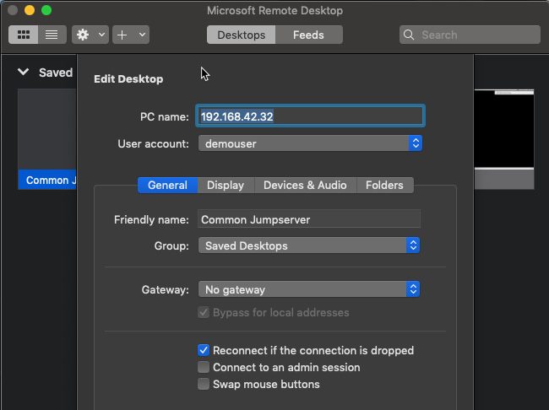

* Create a desktop session for your IP

You should specify the IP you were given (this is just an example) and specify ***demouser*** as the user to connect to.

To access the session:

* Double-click your newly-created desktop
* On the certificate verification dialog click the Continue button to accept the cert

The session will start and you’re ready to test the environment.

### Connecting to the Windows Server via RDP on Windows

Using RDP on a Windows laptop will depend on the Windows OS running. For Windows 7 or Windows 10 you can run **Remote Desktop Connections** from the Start menu.

When configuring the RDP client, you will only need the Computer (which is that network IP address for the Windows Server 2008R2 image). An example is shown below.

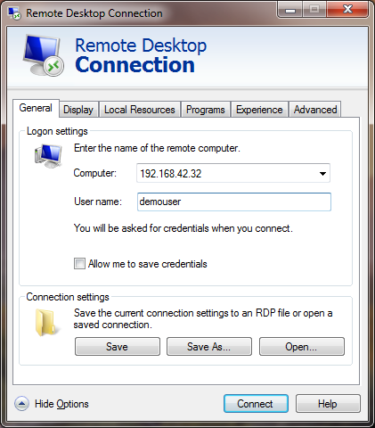

* Specify your IP and the username of ***demouser*** and click Connect
* On the certificate verification dialog click the **Yes** button to accept the cert

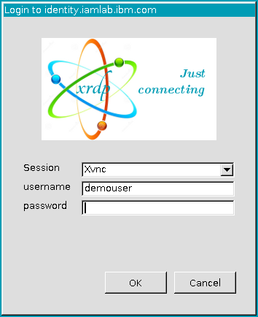

* On the xrdp Login dialog enter the password (Passw0rd) and click the **OK** button

The session will start and you’re ready to test the environment. Proceed to the next chapter.

# Check the IGI Application is Working

Irrespective of the training platform you are running on (local VMs, Skytap, SCS-Portal or local ESX servers) you should now have all the images running and talking to each other. The following checks will confirm that IGI is ready for your lab.

The following steps assume you are logged into the Common Jumpserver image, have the CentOS desktop open and will access everything from there.

## Check Virtual Appliance

We will first check that the Virtual Appliance is running:

* Using the Firefox browser on the Common Jumpserver desktop, go to <https://igiva.iamlab.ibm.com:9443/> or use the “VA via Login” bookmark

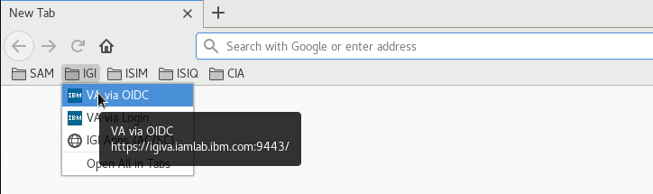

This will redirect you to the OIDC login (<https://igiva.iamlab.ibm.com:10443/login>).

If you have problems starting Firefox from the shortcut on the desktop, you can go to **Applications > Favorites > Firefox** or **Applications > Internet > Firefox**.

* If you are prompted to verify the site self-signed certificate, do so
* Log in with admin/admin

With IGI 5.2.4 and higher, OIDC is the default login mechanism for all IGI UIs, including the Virtual Appliance Local Management Interface (LMI). You can still get to the “old” LMI login prompt by using either <https://applianceHostname:9443/login> (this is a bookmark in Firefox) or <https://applianceHostname:9443/fallback>. To login to the old LMI login use admin/Passw0rd! (note the exclamation mark).

You should be presented with the IBM Security Identity Governance and Intelligence Local Management Interface (LMI), similar to the following.

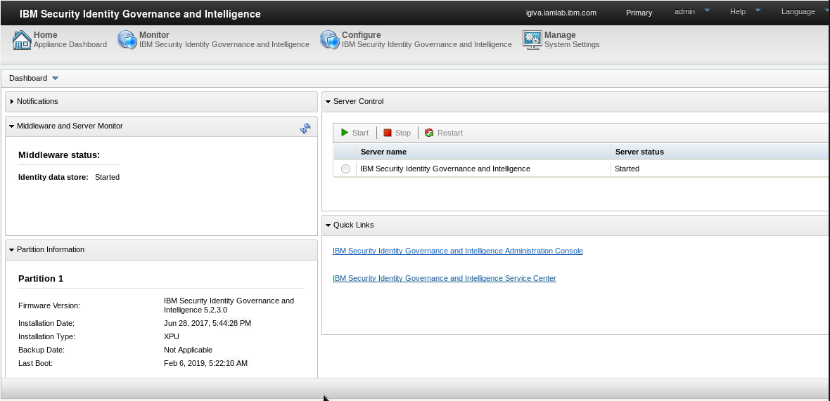

The **Server Control** widget shows that IGI is started. You can see that the **Middleware and Server Monitor** widget is showing that the IGI database is running.

If you are familiar with older versions of IGI, you would notice that the directory status is now gone as the Identity Brokerage no longer uses LDAP.

If your environment matches this, then the Virtual Appliance is running.

## Check IGI

Next, we will check the IGI application.

* Open a new browser tab or window and go to <https://igi.iamlab.ibm.com:9343> or the **IGI Apps (AC/SC)** bookmark

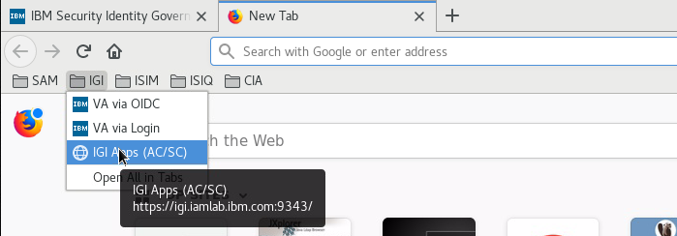

Note – you could have also used the links in the Quick Links widget to go directly to the different IGI UIs.

You will be taken to the common landing page for all IGI UIs.

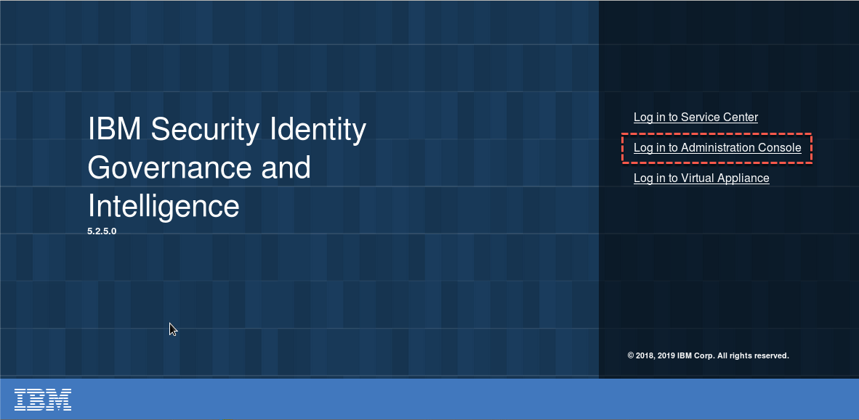

* Select the **Log in to Administration Console** link

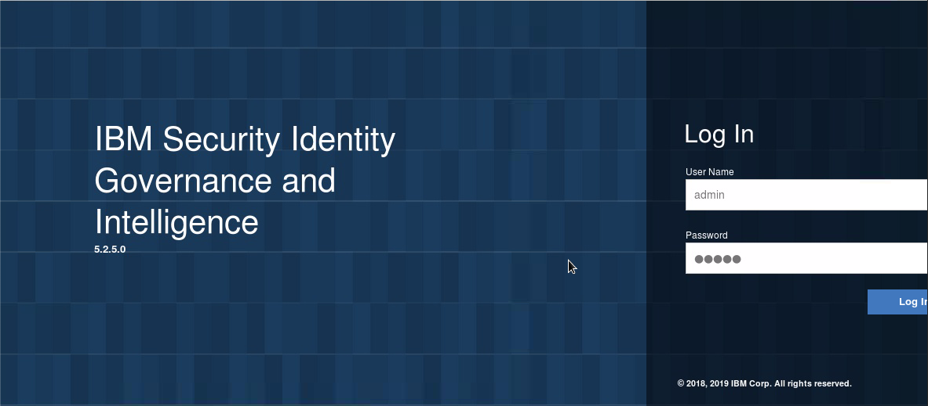

* Log in with admin/admin (they may be pre-populated) and click the Log In button

You should see the IGI Administration (Admin) Console Home page.

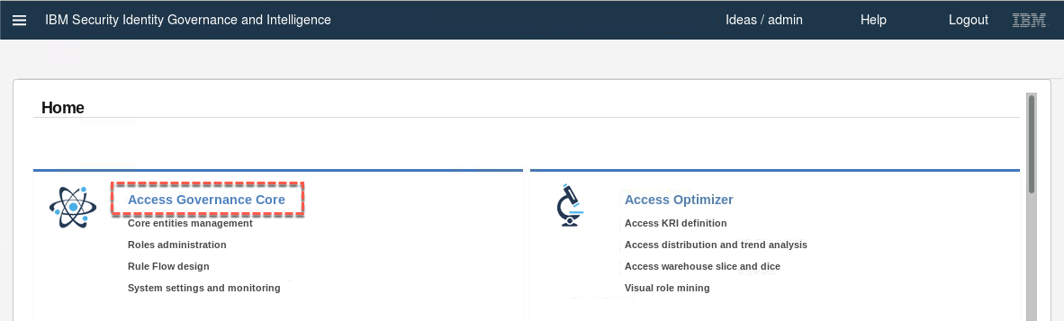

* Click on the **Access Governance Core** module

You should see users displayed under the **Manage > Users** tab.

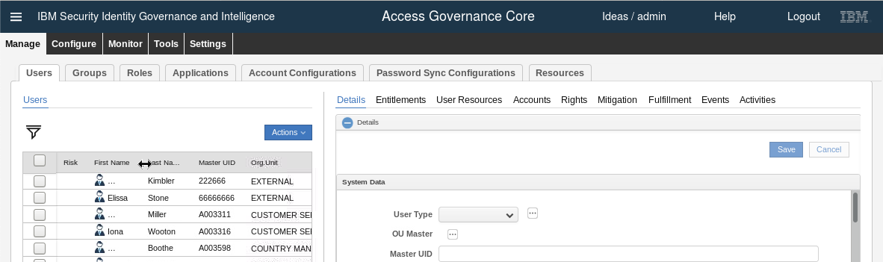

This confirms that the IGI application is running and can communicate with the IGI database.

## Check Enterprise Connectors and Identity Brokerage

The last set of checks relate to the Identity Brokerage module used for connecting to target systems. To confirm its working:

* Go to the **IGI Admin Console Home page** (use the menu icon at the top-left of any screen)
* Click on the **Enterprise Connectors** module

The default view is the **Monitor > Connector Status** tab.

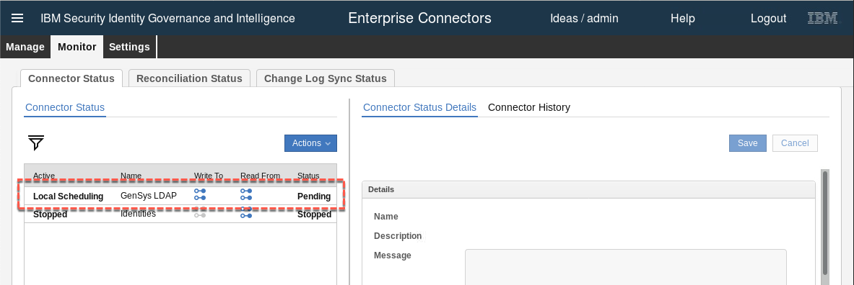

The GenSys LDAP connector is showing as Pending and not In Error. This is a good sign.

* Select the **GenSys LDAP** connector and click on the **Connector History** in the right panel to see the history of when the connector has run

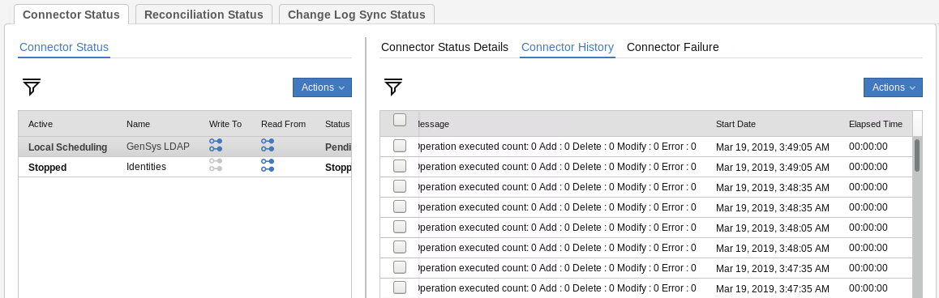

You should see recent activity similar to what is shown above. The times are in GMT (UTC) so you may need to convert to your local time to confirm the activity is recent.

We will now test the end to end components for this LDAP connector (i.e. IGI – Identity Broker – TDI – LDAP)

* Still within the Enterprise Connectors module, go to **Monitor > Change Log Sync Status**
* Select the GenSys LDAP connector (it is in a Stopped state with an error)

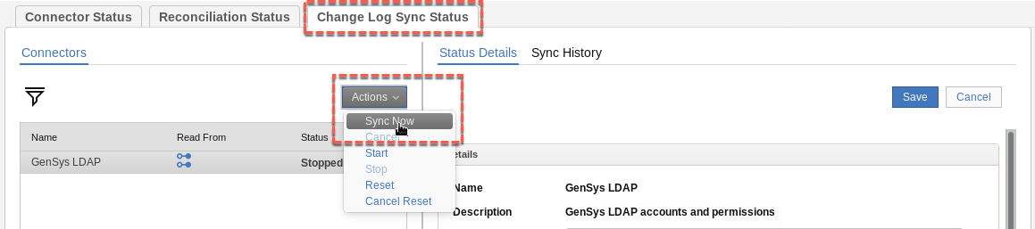

* Select **Actions > Sync Now**

This will initiate a recon from the LDAP target, via TDI to the Identity Brokerage component. Ignore the connection refused error (for some reason it’s not being cleared out from the Status Details tab).

* Select **Sync History** in the right pane to see the results

You should see a recent sync with a success status (green tick icon).

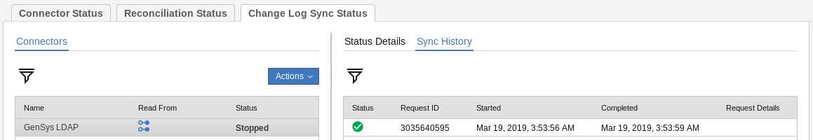

This confirms that all components are running. You are ready to start your lab(s). You are finished with this document and the lab setup.

# Appendices

The appendices are:

A – Local VM Networking Configuration

B –Issues You May Encounter with the Training Environment

C – Environment Utilities

# Appendix A – Local VM Networking Configuration

This appendix contains a number of topics relating to network configuration if you’re running the training environment as VMs on your local machine with VMWare Fusion (Mac), Workstation (Windows, Linux) or Player (free).

The standard network configuration was detailed in Section 3.5 Check the Networking Configuration on page 10. The following sections are considered exception situations.

If you are using one of the other training platforms (Skytap, SCS-Portal or local ESX Servers), you don’t need to worry about this appendix.

## A.1 – Configure New Network in VMWare and Change VMs to Use It

It is assumed that you will use the default NAT network (vmnet8) for the lab images. However, if you don’t want to change the default NAT network, you can create a new network and change the VMs network cards to use it. If you are going to use the default NAT network as described in the main body of this document, do not do these steps.

The process to do this in VMWare Workstation and VMWare Fusion is the same, but the UI is slightly different. The following sections describe the steps for each. Note that old screenshots are used – the VMs you are using are different (refer to the main body of this document).

If you are using VMWare Player on a Windows machine, see the separate steps in

A.2 – Using VMWare Player with the Training Image on page 44.

### A.1.1 – Add a New Network to Workstation and Set VM Network Adapters

To add a new network in VMWare Workstation:

* Start virtual network editor (Edit > Virtual Network Editor)
* Click the Add Network… button
* Select an available network

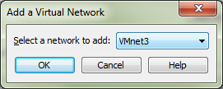

* Click OK
* Select it and enter the following values:
* VMnet Information – Host-only (you can only have one NAT network)
* Select Connect a host virtual adapter to this network
* Select Use local DHCP service to distribute IP address to VMs (not really needed as all the VMs use a fixed IP)
* Set the Subnet IP to 192.168.42.0
* Set the Subnet mask to 255.255.255.0

It should look like the following:

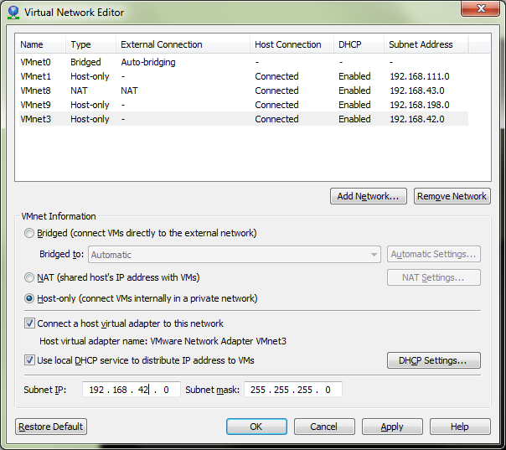

* Click OK

VMWare will go through some steps to reload the network configuration.

Next, we need to go through all VMs in the training environment (IGI Data Server, IGI Virtual Appliance and optionally the Windows Server) and set the network adapters to use the new network.

For each VM:

* Open the VM (don’t start it) and click the Edit Virtual Machine Settings link (or menu VM > Settings)
* Select the Network Adapter
* In the Network connection panel, select the Custom: Specific virtual network
* In the pull-down list, select the new network you created earlier

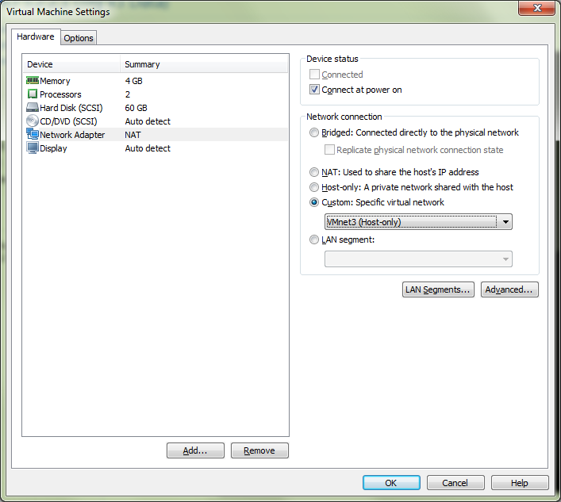

* Repeat for any other network adapters (the Virtual Appliance has three)

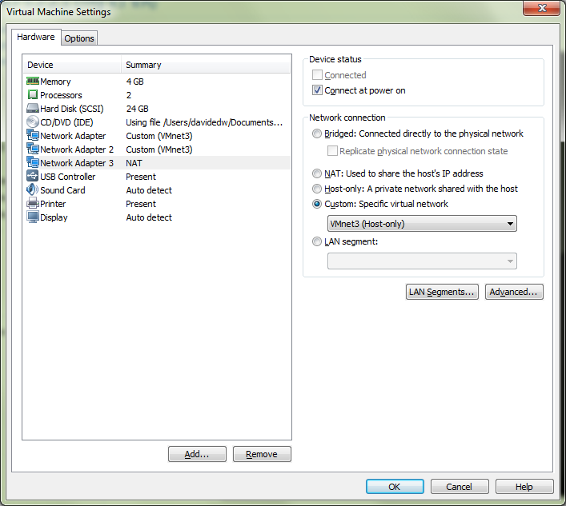

* When you’ve set all network adapter for the VM, click OK

You should see the **Custom (VMnet*)** beside each network interface.

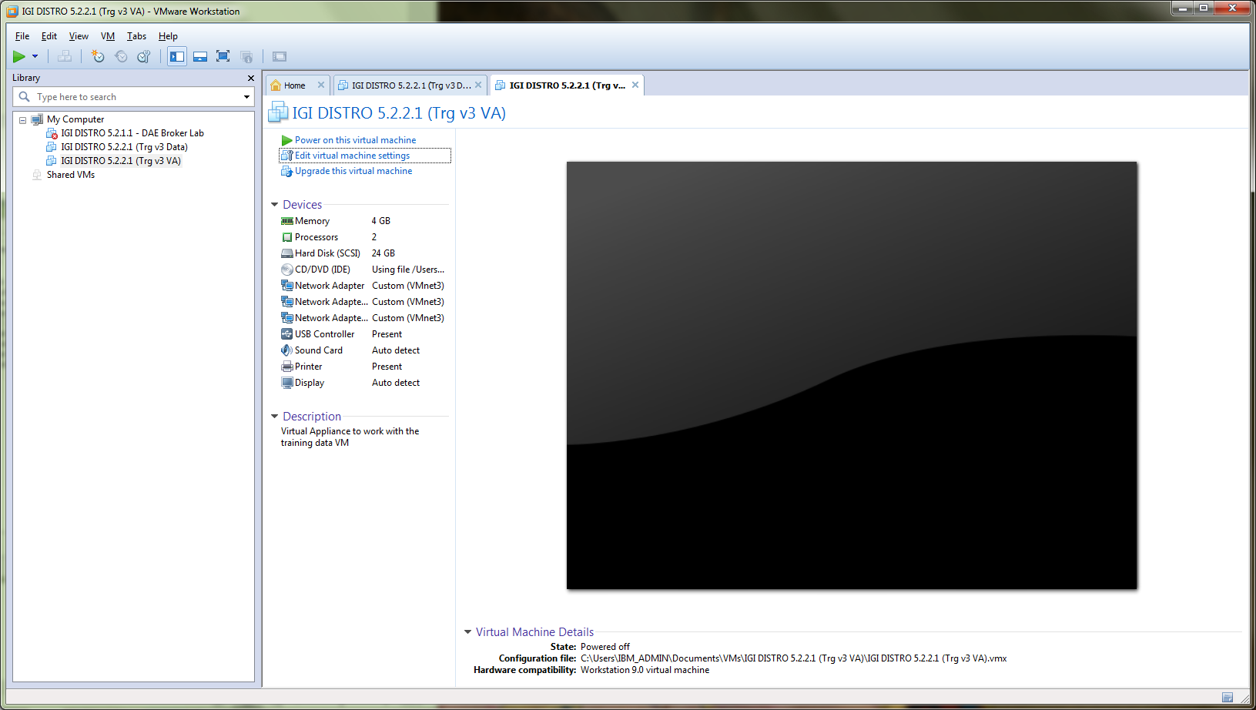

* Repeat for all IGI training VMs.

You can now continue with the steps in the main body of the document.

### A.1.2 – Add a New Network to Fusion and Set VM Network Adapters

To add a new network in VMWare Fusion (Mac):

* Go to VMWare -> Preferences
* Click the Network icon to go to the Network tab
* Click the Lock to Make changes and enter your Mac password when prompted
* Click the Plus sign (+) below the list to add a new network

Fusion will create a new vmnet* (next available number). The example below shows vmnet5, but depending on what you have configured already it may be a different number.

* Set the following values for the existing 192.168.42.0 network:
* “Allow virtual machines on this network to connect to external networks (using NAT)”
* “Connect the host Mac to this network”
* “Provide addresses on this network via DHCP”
* Subnet IP – 192.168.42.0
* Subnet Mask – 255.255.255.0

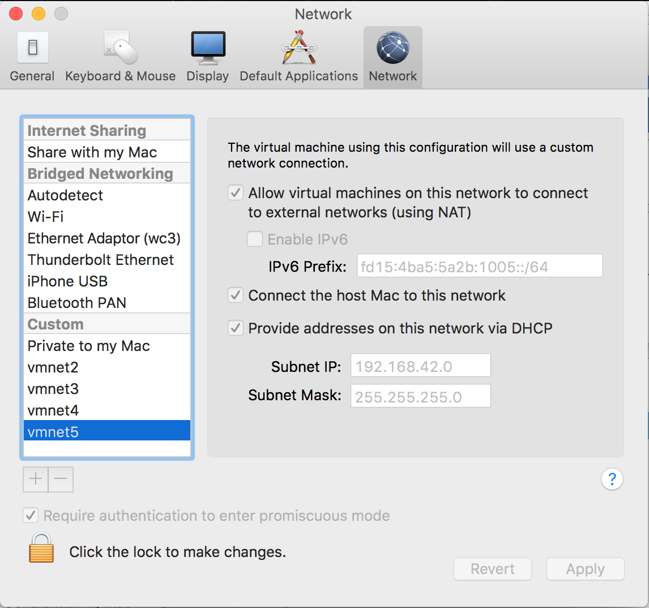

* Click Apply and “Click the lock to make changes”.

Next, we need to go through all VMs in the training environment (IGI Data Server, IGI Virtual Appliance and optionally the Windows Server) and set the network adapters to use the new network.

For each VM:

* In VMWare Fusion, open (but do not start) the virtual machine.
* Click Settings (wrench icon) or Virtual Machine > Settings in the menu.
* Under the Removable Devices title, click on the network adapter(s) you need to modify.

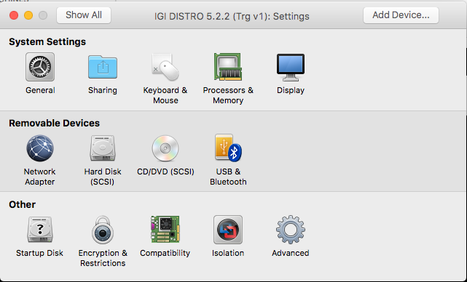

* Ensure the network adapter is the one you set/created in the previous section

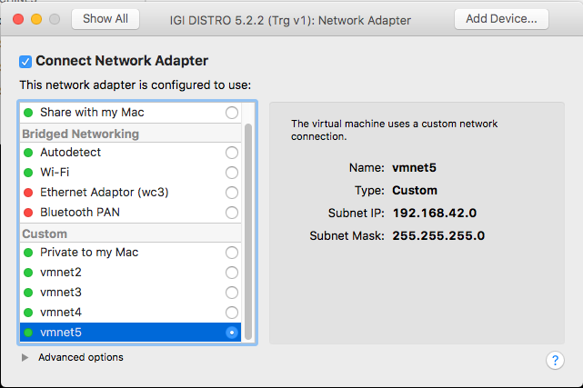

* Close the Settings dialog

All VMs should be able to communicate, as per the checks in the lab guide. If you have problems, check the next section.

## A.2 – Using VMWare Player with the Training Image

You can use VMWare Player to run the training image. It has been used successfully in some classes but requires configuration of both VMWare and the images (similar to above). The following sections describe the steps to do this.

The following steps have not been validated with the current 5.2.5 training image – YMMV.

### A.2.1 – Update the Local Hosts File

You should define hosts entries for the two VMs:

* Use Notepad or Notepad++ to edit C:\Windows\System32\drivers\etc\hosts and add

192.168.42.61 igiva.iamlab.ibm.com

192.168.42.60 igi.iamlab.ibm.com

192.168.42.65 igidb.iamlab.ibm.com

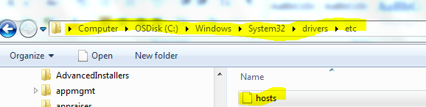

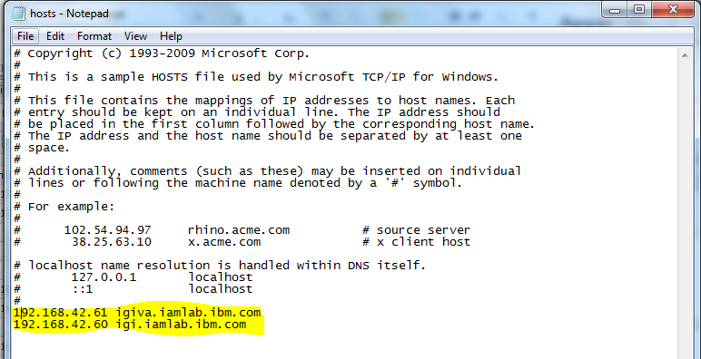

* Save the file.

### A.2.2 – Update Windows Network Setting for vmnet8

The network configuration of the network the VMs will use needs to be changed. To do this:

* Right click on the **Networking** icon in the lower right of the Windows desktop



* Select **Open Network and Sharing Center**
* On the Network and Sharing Center page, select **Change Adapter Settings**

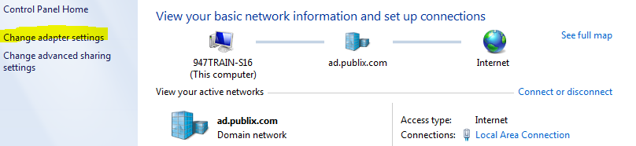

* Double-click the **VMware Network Adapter VMnet8** to open it

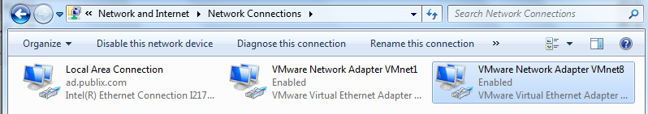

* On the VMware Network Adapter VMnet8 Status dialog, click the **Properties** button
* On the Properties dialog select the **Internet Protocol Version 4 (TCP/IPv4)** and click the **Properties** button

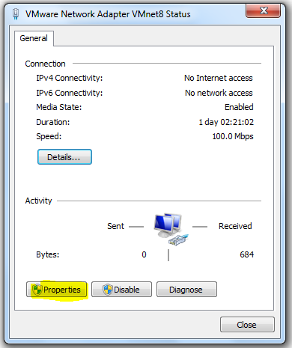🡪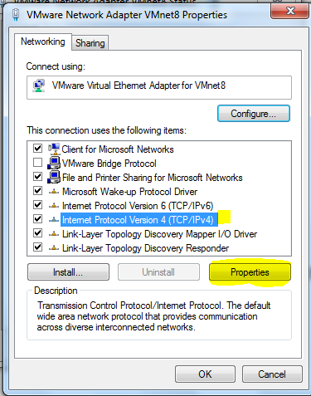

* On the Internet Protocol Version 4 (TCP/IPv4) Properties dialog, change the IP address to be 192.168.4.1 and ensure the subnet is 255.255.255.0.

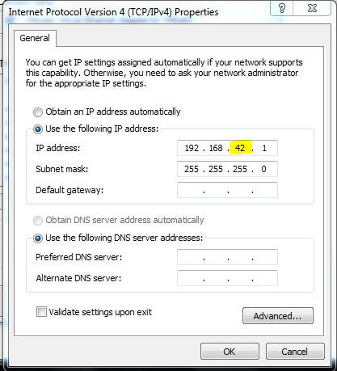

* Click **OK** to save the changes.
* Click **Close** on the Internet Protocol Version 4 (TCP/IPv4) Properties dialog and then on the Internet Protocol Version 4 (TCP/IPv4) Status dialog
* Close the network connections window

### A.2.3 – Update all the VMs to Use the VMnet8

You will need to ensure all VMs are using the VMnet8 network. There is one network card on the data server, three on the virtual appliance and one on each of the Windows servers (if you are using either of them for the labs). To do this:

* Make sure all of the VMs are shutdown
* Open the **VMWare Player** application
* For each VM, right-click and choose **Settings**
* Find and select the **Network Adapter** (for the virtual appliance we will do these steps three times)

The network will be shown as the default NAT. We need to change this to a custom VMnet8.

* Select the radio button beside Custom: Specific virtual network and select VMnet8 (NAT) from the pulldown menu

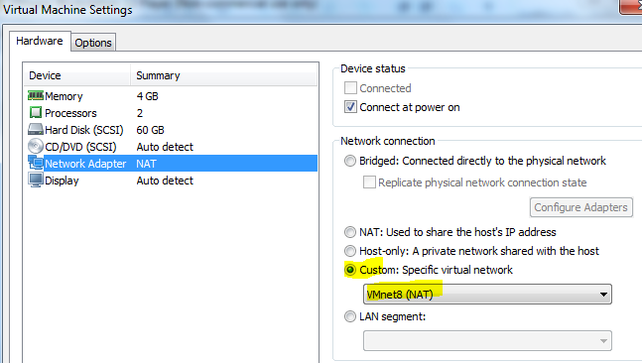

* Repeat for all Network Adapters on the virtual appliance and for all the VMs
* Follow the steps in the next section, which includes the correct VM startup order

End of Appendix A

# Appendix B – Common Issues With the Training Environment

There are some common issues that have been observed with this training environment (particularly the earlier 5.2.3 environment). Many of these should have been resolved with 5.2.5, however some relate to CentOS issues or running in local VMWare environments. This appendix lists some common issues found with the images and how to resolve them.

## B.1 – IGI Data Server Loses eth0

There is a common problem with CentOS where network changes may cause corruption or removal of the eth0 (default Ethernet) definition. This is often seen when the VM is started but the network configuration is not correct, and usually affects the DB Server (igidb.iamlab.ibm.com).

You may see this in the local VM or local ESX environments. You should not see it in the Skytap or SCS-Portal platforms.

To check for the problem:

* Log into the command line (shell) for the offending VM

If you can’t get to the VM (i.e. when running in a local ESX environment) see your instructor.

* At the prompt enter ifconfig

[igi@igi tools]$ ifconfig

eth0 Link encap:Ethernet HWaddr 00:0C:29:F3:86:94

inet addr:192.168.42.60 Bcast:192.168.42.255 Mask:255.255.255.0

inet6 addr: fe80::20c:29ff:fef3:8694/64 Scope:Link

UP BROADCAST RUNNING MULTICAST MTU:1500 Metric:1

RX packets:28018 errors:24448 dropped:0 overruns:0 frame:0

TX packets:26630 errors:0 dropped:0 overruns:0 carrier:0

collisions:0 txqueuelen:1000

RX bytes:4695230 (4.4 MiB) TX bytes:22882814 (21.8 MiB)

Interrupt:18 Base address:0x2024

lo Link encap:Local Loopback

inet addr:127.0.0.1 Mask:255.0.0.0

inet6 addr: ::1/128 Scope:Host

UP LOOPBACK RUNNING MTU:65536 Metric:1

RX packets:62335703 errors:0 dropped:0 overruns:0 frame:0

TX packets:62335703 errors:0 dropped:0 overruns:0 carrier:0

collisions:0 txqueuelen:0

RX bytes:60474509950 (56.3 GiB) TX bytes:60474509950 (56.3 GiB)

If there is no eth0, then you have the issue. If you have an eth0 but you can’t connect to the VM, it may be corrupted.

* In both cases enter the following commands to delete the current definitions (the reboot will rebuild the definitions)

[igi@igi tools]$ cd /etc/udev/rules.d/

[igi@igi rules.d]$ sudo rm 70-persistent-net.rules

[sudo] password for igi:

[igi@igi rules.d]$ sudo reboot

* When the system returns, repeat the ifconfig command from above.

This should resolve the issue. If not speak to your instructor.

## B.2 – Suspended VA Lost Connection to Data Servers

If you suspend and later restore the Virtual Appliance you may find that you cannot log into the application UIs. This may indicate a problem with the applications running on the VA having lost its connections to the data servers (databases or directories).

You could see this on any of the training platforms (local VM, Skytap, SCS-Portal, or local ESX servers).

The simplest remedy to this is to go into the VA Command Line Interface and use the reboot command to restart the VA and all its components.

ispim1.demo.com> help

Current mode commands:

firmware Work with firmware images.

fixpacks Work with fix packs.

ispim Work with the IBM Security Privileged Identity Manager

settings.

license Work with licenses.

lmi Work with the local management interface.

management Work with management settings.

snapshots Work with policy snapshot files.

support Work with support information files.

tools Work with network diagnostic tools.

Global commands:

back Return to the previous command mode.

exit Log off from the appliance.

help Display information for using the specified command.

**reboot Reboot the appliance.**

shutdown End system operation and turn off the power.

top Return to the top level.

ispim1.demo.com> reboot

## B.3 – HTTP 404 With OIDC Login

If you have left a browser session open for some time and you go to one of the login pages that use OIDC, you may see a 404 error trying to login.

To resolve this you can try the following:

1. Close and restart the browser,
2. If that doesn’t work, reboot the IGI VA

This should resolve the issue.

## B.4 – “Time Drift” Problem

This issue is when the clock in the virtual appliance gets out-of-synch with the clock on the data server, normally due to the virtual appliance being suspended.

This is an issue that was common with the older training environment as there was no time synchronization for the VA. With recent releases (and in this 5.2.5 image) OpenVM tools is installed which gets the VA time from the same place as the DB Server so they remain in synch.

This can be a problem with time-based transactions. They are stored in the database (on the data server) but accessed via the application (on the virtual appliance). If the images are shut down for some time and restarted, the data server will set it’s time to the current host time but the VA will still be at the earlier time. The application will not process events as the time on the events in the database are later than the time in the application. This is most apparent in IGI where you will see events sitting in an Unprocessed state.

To correct this time drift, you need to find out the time on the data server and set the VA to match.

To find the time on the data servers:

* The PIM data server is the Windows Server, so just check the date/time shown on the desktop.
* The IGI data server is a Linux system, so run the date command (as shown below):

[igi@igidb ~]$ date

Tue Jul 4 01:55:30 CEST 2017

To set the time on the VA you need to access either the VA Local Management Interface (Web UI) or command line.

On the Local Management Interface go to Manage -> System Settings -> Date/Time

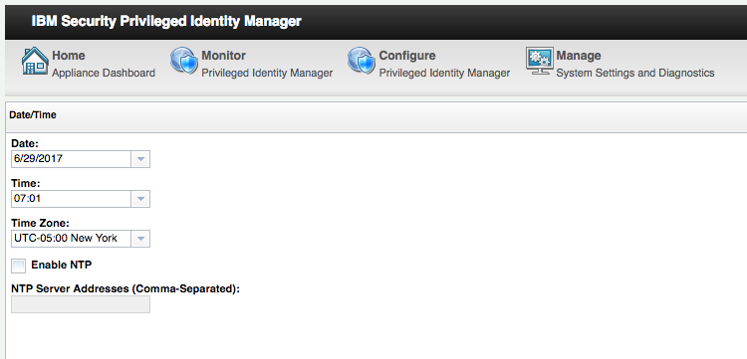

Check the **Time Zone** (and correct if necessary) then set the **Date** and **Time** to match the data server, then click Save Configuration.

If you change the time, you may want to restart the application from the VA LMI Home page.

## B.5 – Intel VT-x Disabled Error

This is an issue that pertains to VMWare Workstation running on some older Windows systems.

You will only see it when running VMs locally, only for Workstation and on older windows machines.

Attempting to start a VM you get an error dialog like the following.

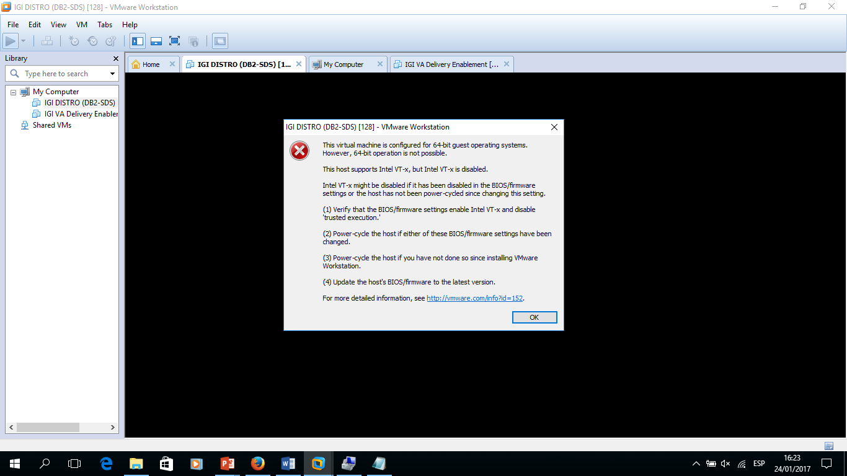

This is an issue with the local machine and BIOS settings.

To resolve the issue, the local machine will need to be rebooted to access the BIOS, then enable both settings (VT-x and VT-d related) under Security -> Virtualization.

For more information see: <https://communities.vmware.com/thread/464586?start=0&tstart=0>

End of Appendix B

# Appendix C – Environment Tools and Utilities

The Common Jumpserver is a Linux CentOS 7 server. It’s designed to serve as the jump box server for the other servers in the training environment. It also contains a number of tools and utilities that may be needed in labs. This appendix summarizes these and how to use them.

## C.1 – LDAP Browser

Some of the provisioning labs may need to explore data in the Directory Server running on the DB Server VM. You can use command line tools, like idsldapsearch, or the GUI Apache Directory Studio.

To access the Apache Directory Studio:

* Open the **utilities** shortcut on the desktop
* Open the **ApacheDirectoryStudio** folder
* Double-click the **ApacheDirectoryStudio** icon

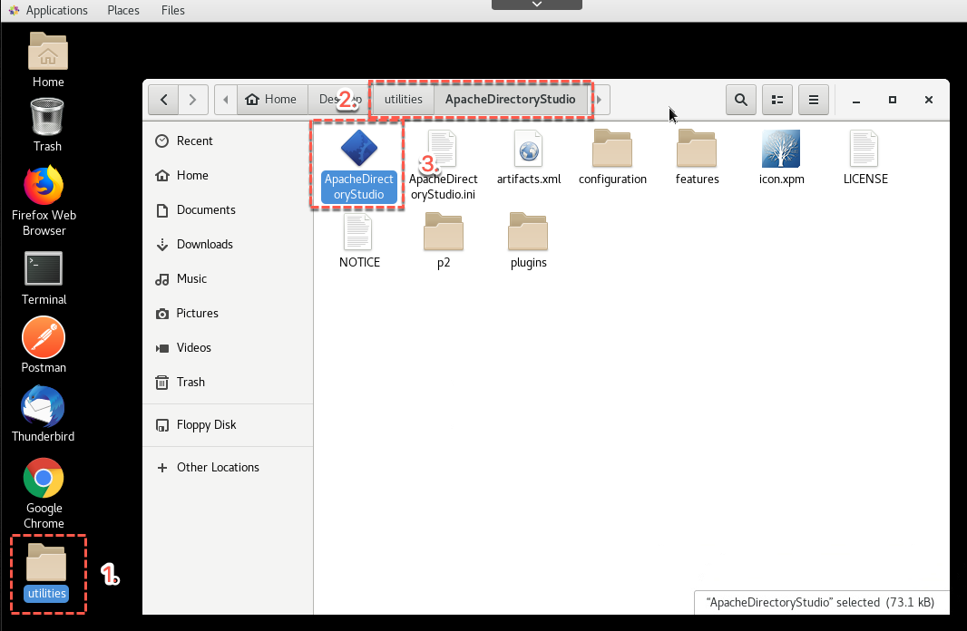

* Once the app has started, click on the SDS on igiva item in the bottom left pane.

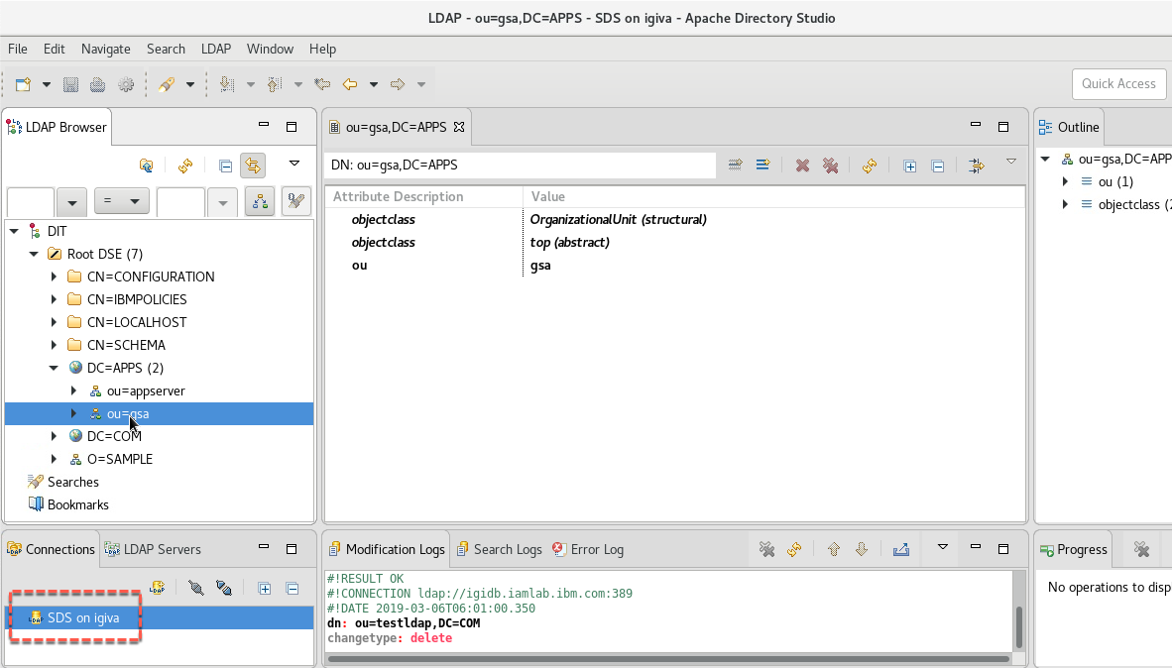

You can now explore the directory tree.

To close, just close the window.

## C.2 – Database Browser

As with the LDAP browser above, you may need to explore the IGI database. The Common Jumpserver image has the DBeaver application installed and configured to connect to the IGI DB.

To access the DBeaver:

* Open the **utilities** shortcut on the desktop
* Open the **dbeaver** folder
* Double-click the **dbeaver** icon

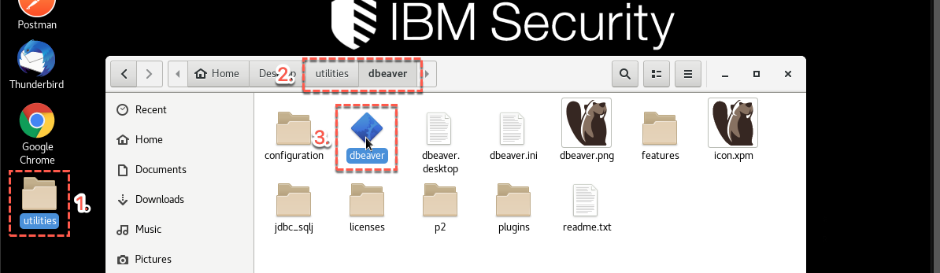

The splash screen will briefly show the components loading. Followed by the DBeaver.

* Ignore any request to update (you don’t need to update)

The igi_db database is already configured and there are some old queries left (tabs in the right pane).

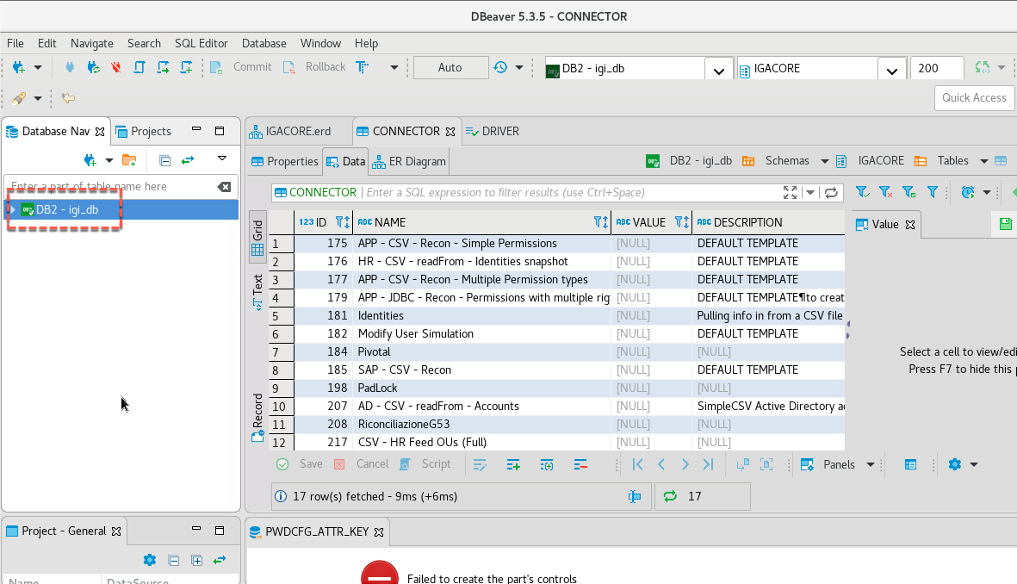

From here you can explore the database.

To close, just close the window.

## C.3 – RDP Client (to RDP from Within the Environment)

You may need to RDP to the AD Server as part of the labs. If you’re running the VMs locally, you can RDP directly to the windows server running AD. If you’re running on Skytap or SCS-Portal, you can connect directly to the desktop.

However, in some situations it may be easier to RDP from the Common Jumpserver into the AD Server.

For this reason, the freerdp client has been installed. To use it:

* From the Common Jumpserver desktop open the Terminal app
* Change to the Desktop/utilities folder
* Run the rdp-to-win2016.sh command

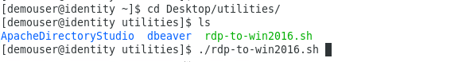

Do not double-click the script from the UI view of the utilities folder. It must run on the command line.

This script is hardcoded to start an RDP session (xfreerdp) to the AD Server (win2016.iamlab.ibm.com) as NetworkAdmin, with a screen size of 1024x768. You can change this script if you need to.

To exit, just close the RDP window

## C.4 – Mail Servers and Clients

Much of IGI’s functionality is driven my email. Many of the labs include configuring or using email. To support this the Common Jumpserver has both email servers (SMTP/IMAP/POP3, from postfix and dovecot) and the Thunderbird email client.

Both are setup and ready to use. IGI is configured to use the postfix SMTP server on the Common Jumpserver (192.168.42.32) – it will send all emails to there. The dovecot server will pickup emails from postfix and Thunderbird will pull them from there and display them.

The mail system is configured so that all emails will appear in the Thunderbird client irrespective of what email address they are for.

To access emails:

* Double-click the Thunderbird shortcut on the desktop
* If needed, accept any self-signed cert messages

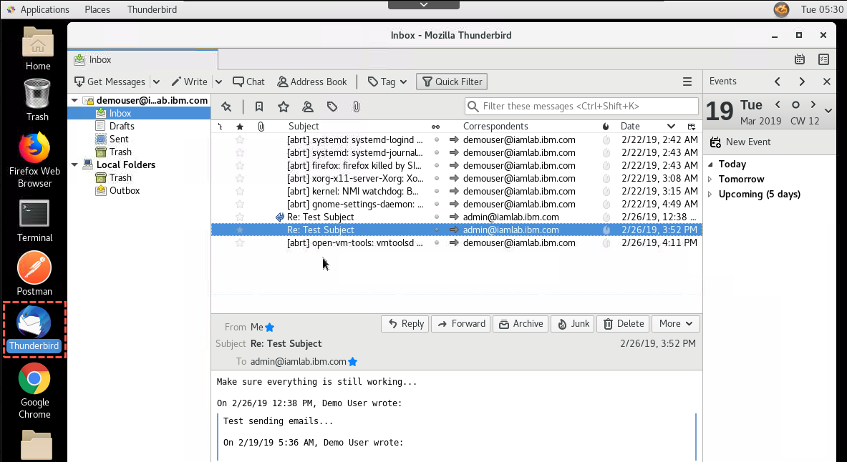

Note that you may see system messages as well as IGI messages.

You can work with emails and use the Get Messages button if needed to pull new messages.

## C.5 – Other Tools and Utilities on the Common Jumpserver

There are some other tools and utilities on the Common Jumpserver that may be of interest:

* DNS – the named application is installed and configured to resolve iamlab.ibm.com addresses
* Postman – whilst not used for the IGI labs currently, there is a postman installation for testing API calls

There may be others on the server.

## C.6 – Tools and Utilities on the DB Server

The DB Server image is based on the old IGI DISTRO image, so the old tools are still there. If you are familiar with the DISTRO, these may be of interest to you. If you haven’t worked with the DISTRO, don’t worry about them.

End of Appendix C

# Notices

This information was developed for products and services offered in the U.S.A. IBM may not offer the products, services, or features discussed in this document in other countries. Consult your local IBM representative for information on the products and services currently available in your area. Any reference to an IBM product, program, or service is not intended to state or imply that only that IBM product, program, or service may be used. Any functionally equivalent product, program, or service that does not infringe any IBM intellectual property right may be used instead. However, it is the user's responsibility to evaluate and verify the operation of any non-IBM product, program, or service.

IBM may have patents or pending patent applications covering subject matter described in this document. The furnishing of this document does not give you any license to these patents. You can send license inquiries, in writing, to:

IBM Director of Licensing  
IBM Corporation  
North Castle Drive  
Armonk, NY 10504-1785 U.S.A.

For license inquiries regarding double-byte character set (DBCS) information, contact the IBM Intellectual Property Department in your country or send inquiries, in writing, to:

Intellectual Property Licensing  
Legal and Intellectual Property Law  
IBM Japan, Ltd.  
19-21, Nihonbashi-Hakozakicho, Chuo-ku  
Tokyo 103-8510, Japan

**The following paragraph does not apply to the United Kingdom or any other country where such provisions are inconsistent with local law :**

INTERNATIONAL BUSINESS MACHINES CORPORATION PROVIDES THIS PUBLICATION "AS IS" WITHOUT WARRANTY OF ANY KIND, EITHER EXPRESS OR IMPLIED, INCLUDING, BUT NOT LIMITED TO, THE IMPLIED WARRANTIES OF NON-INFRINGEMENT, MERCHANTABILITY OR FITNESS FOR A PARTICULAR PURPOSE.

Some states do not allow disclaimer of express or implied warranties in certain transactions, therefore, this statement might not apply to you.

This information could include technical inaccuracies or typographical errors. Changes are periodically made to the information herein; these changes will be incorporated in new editions of the publication. IBM may make improvements and/or changes in the product(s) and/or the program(s) described in this publication at any time without notice.

Any references in this information to non-IBM Web sites are provided for convenience only and do not in any manner serve as an endorsement of those Web sites. The materials at those Web sites are not part of the materials for this IBM product and use of those Web sites is at your own risk.

IBM may use or distribute any of the information you supply in any way it believes appropriate without incurring any obligation to you.

Licensees of this program who wish to have information about it for the purpose of enabling: (i) the exchange of information between independently created programs and other programs (including this one) and (ii) the mutual use of the information which has been exchanged, should contact:

IBM Corporation  
2Z4A/101  
11400 Burnet Road  
Austin, TX 78758 U.S.A.

Such information may be available, subject to appropriate terms and conditions, including in some cases payment of a fee.

The licensed program described in this document and all licensed material available for it are provided by IBM under terms of the IBM Customer Agreement, IBM International Program License Agreement or any equivalent agreement between us.

Any performance data contained herein was determined in a controlled environment. Therefore, the results obtained in other operating environments may vary significantly. Some measurements may have been made on development-level systems and there is no guarantee that these measurements will be the same on generally available systems. Furthermore, some measurement may have been estimated through extrapolation. Actual results may vary. Users of this document should verify the applicable data for their specific environment.

Information concerning non-IBM products was obtained from the suppliers of those products, their published announcements or other publicly available sources. IBM has not tested those products and cannot confirm the accuracy of performance, compatibility or any other claims related to non-IBM products. Questions on the capabilities of non-IBM products should be addressed to the suppliers of those products.

All statements regarding IBM's future direction or intent are subject to change or withdrawal without notice, and represent goals and objectives only.

All IBM prices shown are IBM's suggested retail prices, are current and are subject to change without notice. Dealer prices may vary.

This information is for planning purposes only. The information herein is subject to change before the products described become available.

This information contains examples of data and reports used in daily business operations. To illustrate them as completely as possible, the examples include the names of individuals, companies, brands, and products. All of these names are fictitious and any similarity to the names and addresses used by an actual business enterprise is entirely coincidental.

**COPYRIGHT LICENSE:**

This information contains sample application programs in source language, which illustrate programming techniques on various operating platforms. You may copy, modify, and distribute these sample programs in any form without payment to IBM, for the purposes of developing, using, marketing or distributing application programs conforming to the application programming interface for the operating platform for which the sample programs are written. These examples have not been thoroughly tested under all conditions. IBM, therefore, cannot guarantee or imply reliability, serviceability, or function of these programs. You may copy, modify, and distribute these sample programs in any form without payment to IBM for the purposes of developing, using, marketing, or distributing application programs conforming to IBM's application programming interfaces.

Each copy or any portion of these sample programs or any derivative work, must include a copyright notice as follows:

© IBM 2017. Portions of this code are derived from IBM Corp. Sample Programs. © Copyright IBM Corp 2017. All rights reserved.

If you are viewing this information in softcopy form, the photographs and color illustrations might not be displayed.

**Trademarks**

IBM, the IBM logo, and ibm.com are trademarks or registered trademarks of International Business Machines Corp., registered in many jurisdictions worldwide. Other product and service names might be trademarks of IBM or other companies. A current list of IBM trademarks is available on the Web at Copyright and trademark information at ibm.com/legal/copytrade.shtml.

**Statement of Good Security Practices**

IT system security involves protecting systems and information through prevention, detection and response to improper access from within and outside your enterprise. Improper access can result in information being altered, destroyed, misappropriated or misused or can result in damage to or misuse of your systems, including for use in attacks on others. No IT system or product should be considered completely secure and no single product, service or security measure can be completely effective in preventing improper use or access. IBM systems, products and services are designed to be part of a comprehensive security approach, which will necessarily involve additional operational procedures, and may require other systems, products or services to be most effective. IBM DOES NOT WARRANT THAT ANY SYSTEMS, PRODUCTS OR SERVICES ARE IMMUNE FROM, OR WILL MAKE YOUR ENTERPRISE IMMUNE FROM, THE MALICIOUS OR ILLEGAL CONDUCT OF ANY PARTY.

© International Business Machines Corporation 2017

International Business Machines Corporation  
New Orchard Road Armonk, NY 10504

Produced in the United States of America 01-2016

All Rights Reserved

References in this publication to IBM products and services do not imply that IBM intends to make them available in all countries in which IBM operates.